
Hormel Foods Corporation (Hormel)
Identity Management Foundation
Design Document Phase 2

Contents
Version Control 8
Revision History 8
Review History 8
Approval History 9
Abbreviation 9
1 Introduction 11
1.1 Executive Summary 11
1.2 Design Principles 11
1.2.1 Establish IAM as a service 11
1.2.2 Secure by default 11
1.2.3 Provide resilience 11
1.2.4 Optimize processes 11
1.2.5 Prioritize user experience 11
1.2.6 Adopt best practices 11
1.3 Design Layers 12
1.3.1 Conceptual Design 12
1.3.2 Logical Design 12
1.3.3 Physical Design 12
1.3.4 Operations Design 12
1.4 Open Items 12
1.5 Assumptions <TBD> 14
1.6 Intended Audience 14
2 Saviynt Security Manager Overview 15
2.1 Saviynt Identity Manager 15
2.2 Saviynt Identity Manager Certification Campaign 15
2.3 SSM Connectors 16
3 Conceptual Design 17
3.1 Actors / Personas 17
3.2 Conceptual Solution 18
3.3 User Experience 20
3.3.1 Access Requester Experience 20
3.3.2 Approver Experience 22
3.3.3 Landing Page Shortcuts 24
3.3.4 Password Reset 25
3.3.5 Certification Campaign 31
4 Logical Design 34
4.1 Naming Conventions 34
4.2 Applications 34
4.3 HFC Active Directory Connector Design 35
4.3.1 User Account Correlation Rule 35
4.3.2 Reconciliation Attribute Mapping 36
4.3.3 Update Service account Type 38
4.4 DMZ Active Directory Connector Design 38
4.4.1 User Account Correlation Rule 38
4.4.2 Provisioning Attribute Mapping 39
4.4.3 Reconciliation Attribute Mapping 40
4.4.4 DMZ Active Directory Maintenance Account Creation 42
4.4.5 DMZ Active Directory Service Account Creation 43
4.4.6 DMZ Active Directory Account Disable 44
4.4.7 DMZ Active Directory Account Deletion 45
4.4.8 DMZ Active Directory Account Rehire 45
4.5 iSeries (ASDPT001) Connector Design 46
4.5.1 User Account Correlation 46
4.5.2 Reconciliation Attribute Mapping 46
4.6 SMART Connector Design 47
4.6.1 User Account Correlation Rule 47
4.6.2 Reconciliation Attribute Mapping 48
4.7 CF PLUS Connector Design 49
4.7.1 User Correlation Rule 49
4.7.2 Reconciliation Attribute Mapping 49
4.8 User Manager Certification 50
4.9 Service Account Owner Certification 51
4.10 Approval Workflows 53
4.11 Reconciliation 54
4.11.1 Account and Access Reconciliation – File Based Import 54
4.12 DMZ AD Account Password Reset 55
4.12.1 Process#2.1 – Maintenance Account Password Reset 55
4.12.2 Process#2.2 – Service and Generic Account Password Reset 55
4.12.3 DMZ Account Password Policy 56
4.13 Business Rules 57
4.14 Scheduled Tasks 57
5 Physical Design 59
5.1 Physical Architecture Overview 59
5.1.1 Development Environment 59
5.1.2 Production Environment 60
5.1.3 Environment Mapping with Connected Systems 61
5.2 Hardware Components 62
5.2.1 Server Pre-requisites 62
5.2.2 High Availability 62
6 Operations Design 63
6.1 Security 63
6.1.1 Authentication 63
6.1.2 Saviynt Operational Roles 63
6.2 Deployment Methodology 63
6.3 Backup and Recovery 64
6.3.1 DR Terminology 64
6.3.2 High-Level Backup and Archival Strategy 64
6.4 Patch and Upgrades 64
6.5 Health check monitoring 65
6.6 Logging 65
6.7 Certificates 65
6.8 Reports 65
7 Requirements Traceability Matrix 66
8 Design Challenges and Decisions 68
9 Appendix 69
9.1 Key Terminologies 69
9.2 Notifications 69
9.2.1 N01# DMZ Active Directory User Account Creation 70
9.2.2 N02# DMZ Active Directory User Account Disable 70
9.2.3 N03# DMZ Active Directory User Account Enable 71
9.2.4 N04# DMZ Active Directory User Account Deleted 71
9.2.5 N09# Access Request Assignment Email Notification 72
9.2.6 N10# Access Request Reminder Email Notification 73
9.2.7 N11# Access Request Reassignment Email Notification 73
9.2.8 N12# Access Request Approved Email Notification 74
9.2.9 N13# Access Request Rejected Email Notification 75
9.2.10 N14# Access Request Expired Email Notification 75
9.2.11 N15# Account Request Assignment Email Notification 76
9.2.12 N16# Account Request Reminder Email Notification 77
9.2.13 N17# Account Request Reassignment Email Notification 77
9.2.14 N18# Account Request Approved Email Notification 78
9.2.15 N19# Account Request Rejected Email Notification 79
9.2.16 N20# Account Request Expired Email Notification 79
9.2.17 21# DMZ Active Directory Account Deleted Today Report 80
9.2.18 N25# Reconciliation Job Failure Report 80
9.2.19 N26# DMZ Active Directory Task Failure Report 81
9.2.20 N27# User Manager Campaign Notification 81
9.2.21 N28# Service Account owner campaign Notification 81
9.3 Certification Campaign 82
9.3.1 User manager campaign 82
9.3.2 Service Account Owner campaign 82

Table of Tables
Table 1: Open Items 12
Table 2: Assumptions 14
Table 3: SSM Connector. 16
Table 4: Actors/Personas 17
Table 5: Key Components 19
Table 6: Landing Page Shortcuts 25
Table 7: Naming Convention 34
Table 8: Application List 34
Table 9 : Active Directory Correlation Rule 35
Table 10 : HFC AD Reconciliation Attribute Mapping 36
Table 11 : Service Account Type 38
Table 12 : DMZ Active Directory Correlation Rule 38
Table 13 : DMZ AD Provisioning Attribute Mapping 39
Table 14 : DMZ AD Reconciliation Attribute Mapping 40
Table 15 : Account Reconciliation Attribute Mapping 47
Table 16 : Entitlement Reconciliation Attribute Mapping 47
Table 17 : SMART Correlation Rule 48
Table 18 : Account Reconciliation Attribute Mapping 48
Table 19 : Entitlement Reconciliation Attribute Mapping 48
Table 20 : Active Directory Correlation Rule 49
Table 21 : CF Plus Account Reconciliation Attribute Mapping 49
Table 22 : CF Plus Entitlement Reconciliation Attribute Mapping 50
Table 23: Approval Process and Level 53
Table 24: DMZ Active Directory Password Policy Service account 56
Table 25: Business Rule 57
Table 26: Scheduled Task 58
Table 27: Environment Mapping with Connected System 61
Table 28: DEV Environment Details 61
Table 29: UAT Environment Details 61
Table 30: PROD Environment Details 61
Table 31: Server Pre-Requisites 62
Table 32: High Availability 62
Table 33: Authentication 63
Table 34: Saviynt Operational Roles 63
Table 35 : DR Terminology 64
Table 36: Patch and Upgrade 64
Table 37: Health Check Monitoring 65
Table 38: Saviynt Analytics Report 65
Table 39: Requirement Traceability Matrix 66
Table 40: Design Challenges and Decision 68
Table 41: Key Terminologies 69
Table 42: DMZ Active Directory User Account Creation 70
Table 43: DMZ Active Directory User Account Disable 70
Table 44: DMZ Active Directory User Account Enable 71
Table 45: DMZ Active Directory User Account Deleted 71
Table 46: Access Request Assignment Email Notification 72
Table 47: Access Request Reminder Email Notification 73
Table 48: Access Request Reassignment Email Notification 73
Table 49: Access Request Approved Email Notification 74
Table 50: Access Request Rejected Email Notification 75
Table 51: Access Request Expired Email Notification 75
Table 52: Account Request Assignment Email Notification 76
Table 53: Account Request Reminder Email Notification 77
Table 54: Account Request Reassignment Email Notification 77
Table 55: Account Request Approved Email Notification 78
Table 56: Account Request Rejected Email Notification 79
Table 57: Account Request Expired Email Notification 79
Table 58: DMZ Active Directory Account Deleted Today Report 80
Table 59: Reconciliation Job Failure Report 80
Table 60: Active Directory Task Failure Report 81

Table of Figures
Figure 1: Saviynt Cloud Access Governance and Intelligence 15
Figure 2: IDM Architecture 18
Figure 3: Request Access 20
Figure 5: Add to Cart 21
Figure 6: Select Access 21
Figure 7: Add Business Justification 22
Figure 8: Request Approval (tile or tab) 22
Figure 9: User Request ID 23
Figure 10: Accept/Reject Request 23
Figure 11: Add Comment and Submit 24
Figure 12: Confirm Request 24
Figure 13: Request Completed 24
Figure 14 : ARS Page 26
Figure 15 : Cart 26
Figure 16 : Checkout Page 27
Figure 17 : Change Password 27
Figure 18 : New Password 28
Figure 19 : ARS Tab 29
Figure 20 : Change Password for Service Account 30
Figure 21 : Set Password 30
Figure 22 : Password Reset Completed 31
Figure 23 : Attestation 31
Figure 24 : Employment verification 32
Figure 25 : Access Verification 32
Figure 26 : Certification completed 33
Figure 27: DMZ AD Account Creation 42
Figure 28: DMZ AD Service and Generic Account Creation 43
Figure 29: DMZ AD Maintenance Account Disable 44
Figure 30: DMZ AD Maintenance Account Deletion 45
Figure 31: DMZ AD Maintenance Account Rehire 46
Figure 32 : User Manager Campaign 51
Figure 33 :Set Primary Certifier for Service Account Owner Campaign 52
Figure 34 : Service Account Owner Campaign 52
Figure 35: DMZ Active Directory - Maintenance Account Password Reset 55
Figure 36: DMZ Active Directory - Maintenance Account Password Reset 55
Figure 37: DEV Physical Architecture 59
Figure 38: PROD Physical Architecture 60

Version Control

Revision History
This section represents the change history of the document. All revisions of the document must be tracked by identifying a new version number, the date it was modified, the person making the change, and the reason for the change.
Version | Date | Author | Comments
0.1 | 09/19/2020 | Ajinkya Chavan
0.2 | 10/11/2021 | Sai Mulam | KPMG internal review.
0.3 | 10/12/2021 | Ajinkya Chavan | Incorporate Sai’s comments
0.4 | 10/13/2021 | Sai Mulam | Final review

Approval History
The signing of this document acknowledges everyone’s concurrence with the validity and accuracy of the information contained in this document.
Version | Approved By | Date
0.4 | Sai Mulam | 10/13/2021

Abbreviation
Abbreviation | Terms | Description
SSM | Saviynt Security Manager | Saviynt’s identity management product name
IAM | Identity Access Management | IAM refers to a framework of policies and technologies for ensuring that the people in an enterprise have the appropriate access to technology resources
DN | Distinguished Name | Every entry in the directory has a distinguished name (DN). DN is the name that uniquely identifies an entry in the directory. The first component of the DN is referred to as the Relative Distinguished Name (RDN).
OU | Organizational Unit | An organizational unit (OU) is a subdivision within an Active Directory into which you can place users, groups, computers, and other organizational units
HTTP | Hypertext Transfer Protocol | An application protocol for distributed, collaborative, and hypermedia information systems.
HTTPS | Hypertext Transfer Protocol Secure | An application protocol for distributed, collaborative, and hypermedia information systems through an encrypted channel.
SSL | Secure Sockets Layer | Standard security technology for establishing an encrypted link between a server and a client.
OOTB | Out-of-the-Box | Standard/default configuration that doesn’t require any special customization
TCP | Transmission Control Protocol | The Transmission Control Protocol is one of the main protocols of the Internet protocol suite. It originated in the initial network implementation in which it complemented the Internet Protocol.
LDAP | Lightweight Directory Access Protocol | The Lightweight Directory Access Protocol is an open, vendor-neutral, industry-standard application protocol for accessing and maintaining distributed directory information services over an Internet Protocol network

Introduction

Executive Summary
Hormel Foods Corporation (Hormel) has embarked upon a technology-driven transformation initiative for its Identity and Access Management (IAM) program called Access Central. The key objective of this initiative is to implement certification campaign for disconnected (SMART, ASDPT001)and connected (CF Plus , DMZ AD, HFC AD) application manage provision and deprovision maintenance and service account for DMZ application.
The purpose of this document is to define the logical, physical, and operational architectures as well as the design details, decisions, and approaches that are taken for implementing the solution. This document details design solution for certification campaign and DMZ AD provisioning/deprovision across all environments: DEV, UAT and PROD.

Design Principles
The IAM team will be guided by the following principles for all design decisions and approaches covered in this design document.

Establish IAM as a service
Provide IAM as a service and promote re-usability, granularity, modularity, loose coupling, and interoperability in solution design. Enterprise applications leverage IAM infrastructure to assess the “rights and privileges” of a user or application and then provide access accordingly.

Secure by default
Features and data can only be accessed when access has been explicitly assigned and are protected from unintended or unauthorized access, change or destruction by leveraging the principle of least privilege. This includes protection from unplanned events and natural disasters. The solution defaults to a secure version of the transport protocol for information transfer and will encrypt all information while it is at rest.

Provide resilience
IAM infrastructure will be implemented such that there is no single point of failure and provides services exceeding the standard expected load to ensure the availability of integrated applications.

Optimize processes
Reduce manual processes as they can be error-prone, may introduce new risks and is costly to maintain. Redesign existing processes to embrace simplicity and reduce complexity. Encourage automation wherever it is practical and cost-efficient.

Prioritize user experience
Implement usable security. Security must not discourage users from using information systems. Instead, security should complement the user experience.

Adopt best practices
Adopt industry best practices and standards while implementing security standards. Security threats are ever evolving and so are security standards safeguarding against them.

Design Layers
The presentation of this design document has been structured into four main aspects: Conceptual Design, Logical Design, Physical Design, and Operations Design, each going into more details from conceptual ideation to physical implementation and sustenance considerations. In addition, the document also details the reason for specific implementation approaches wherever design challenges were identified.

Conceptual Design
Conceptual Design captures a big-picture vision of the whole solution. This design identifies the major functional components needed to provide the core business/mission capabilities within the solution, describes the relationship to the various organizations interacting with the solution’s building blocks, the purpose of each building block component, and the interrelationships among the functional components.

Logical Design
Logical Design describes these software components and the information and control flows among the components within the system. It results from allocating the functional components in the logical design to software components identified from requirements analysis and early design work.

Physical Design
Physical Design describes the mapping of all software components to hardware components and detailed information and control flows. It includes connections to internal and external networks; incorporation of security features and devices, component integration mechanisms, and component scaling mechanisms needed to meet non-functional requirements.

Operations Design
Operations Design describes support for various capabilities required for sustenance of the system before, during and after go-live. This includes security, deployment, upgrade and patching, backup and recovery, logging, health check, and reports

Open Items
Table 1: Open Items
S.no | Risk/Issues | Description | Comments | Status
1 | FTP connection to Saviynt | Require access to FTP server to pull csv files into Saviynt for DEV,UAT,PROD | 08/18 :- Wes has started discussion with Tony and Nate | Open
1 | FTP connection to Saviynt |  | 09/10:- KPMG team shared FTP server design detail. | Open
1 | FTP connection to Saviynt |  | 09/15:- Work ticket has been submitted for FTP server | Open
2 | SMART and iSeries application file format in CSV | We would require file in CSV format to process into Saviynt. | 07/29:- KPMG team has share csv file format with Hormel. | Open
2 | SMART and iSeries application file format in CSV | We would require file in CSV format to process into Saviynt. | 08/06:- Wes is checking with application team. | Open
2 | SMART and iSeries application file format in CSV | We would require file in CSV format to process into Saviynt. | 09/15:- Hormel team is working on file format. | Open
3 | CF Plus application database connection | We would require access to CF plus database application to fetch account and entitlement details for DEV,UAT,PROD | 08/10 :- KPMG team has requested for CF PLUS DB access. | Closed
3 | CF Plus application database connection |  | 09/03:- CF application service account creation owner is on leave till next week. | Closed
3 | CF Plus application database connection |  | 09/14:- Saviynt able to connect with CF plus | Closed
4 | User Manager/Service account certification Email template | Hormel team needs to review email template for certification campaign | 08/18 :- Hormel team has reviewed user manager campaign template. | Open
4 | User Manager/Service account certification Email template |  | 08/19:- KPMG team will share Service account email template for review. | Open
4 | User Manager/Service account certification Email template |  | 09/06 : KPMG team has configured User manager campaign as per comments. | Open
4 | User Manager/Service account certification Email template |  | 08/26: KPMG team has configured email template for service account campaign. | Open
4 | User Manager/Service account certification Email template |  | 09/15: KPMG team will send final version of email template for Hormel review. | Open
5 | Demo on DMZ provisioning | KPMG team will show case demo on DMZ account Joiner and leaver process | 08/19: - KPMG team is planning to schedule on Monday. | Closed
5 | Demo on DMZ provisioning |  | 08/26 :- KPMG showcase workflow and request summary. Next session will be scheduled to demonstrate workflow. | Closed
5 | Demo on DMZ provisioning |  | 09/10 : KPMG showcase demo for DMZ provisioning, approval, enable, disable and password functionality. | Closed
6 | Demo on DMZ account password Reset Functionality | KPMG team will show case demo on DMZ account Password reset functionality | 08/19: - KPMG team is planning to schedule on Monday. | Closed
6 | Demo on DMZ account password Reset Functionality |  | 08/26 :- KPMG showcase workflow and request summary. Next session will be scheduled to demonstrate workflow. | Closed
6 | Demo on DMZ account password Reset Functionality |  | 09/15: - Meeting need to schedule to discuss DMZ password policy | Closed
6 | Demo on DMZ account password Reset Functionality |  | 09/21 :- Tony has shared password policy for DMZ AD. | Closed
7 | All HFC AD Maintenance accounts must be updated with Emploee Number | HFC AD Maintenance accounts employeenumber attribute is required to correlate HFC AD account with user on Saviynt | 09/22 : Nathan is working on it. Need confirmation whether employeenumber is updated on HFC AD maintenance account | Open

Assumptions <TBD>
Table 2: Assumptions
# | Assumption
 | SMART,CF Plus, iSeries (ASDPT001) will be set as only reconciliation and actual removal of account and entitlement will be out of scope
 | For DMZ AD and HFC AD only account certification campaign will be configured, and entitlement certification will be out of scope.
 | SMART and iSeries (ASDPT001) will be disconnected applications and data will be fed from flat file
 | Pending worker will be not be included in certification
 | Birthright access for DMZ Active Directory account is out of scope.
 | Inactive and Orphan accounts will not be part of certification.
 | Group provision for DMZ AD will be out of scope
 | For iSeries application only ASDPT001 will be in scope.
 | Disable and Remove account for DMZ AD functionality will be disabled while requesting account.
 | HFC Active Directory and DMZ AD maintenance account employee numbers must be updated on AD before reconciliation.
 | All service account owners must be populated through CSV file.

Intended Audience
- The primary audience for this document is the enterprise architects and business process owners at Hormel who are responsible for maintenance and sustenance of Identity and Access Management processes, automation, and security.
- This document will be referred by the development team to implement and deliver the solution.
- Additionally, the document should be reviewed by Application Owners and Technical Architects of the respective application (HFC Active Directory, DMZ Active Directory, SMART,CF Plus, and iSeries (ASDPT001)).
- The document lays out specific details regarding hardware and networking requirements, which should be reviewed by Hormel’s network and infrastructure teams.

Saviynt Security Manager Overview
Saviynt is a cloud-native Identity Governance and Administration (IGA) platform that protects an organization's most sensitive information and increases your organizational efficiency and agility by ensuring that the right people have the right access to the right resources for only the right amount of time.
It is a leading provider of Cloud Security and Identity Governance solution that provides a single platform to secure applications, data in Cloud (E.g.: Office 365, AWS, Azure, Salesforce, Workday) and On-premises (E.g.: SAP, Oracle EBS) systems.
Saviynt’s platform unifies accounts across the ecosystem, creating one identity with fine-grained entitlements for each user. Saviynt automates account and access provisioning aligned with organizational risk tolerance and workflows so organizations can reduce human error risk, accelerate onboarding, and holistically view all users’ access.
Figure 1: Saviynt Cloud Access Governance and Intelligence
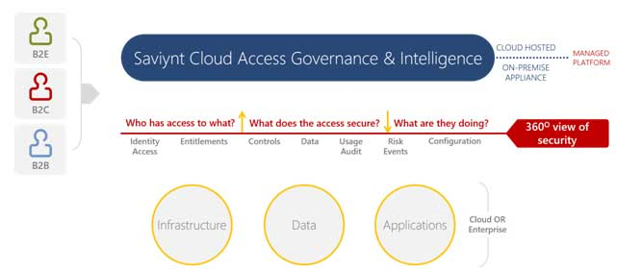
The following are the key components of the Saviynt Security Manager that would be used as part of this design.

Saviynt Identity Manager
Saviynt Identity Manager provides user access provisioning, de-provisioning, and Identity Governance and Administration (IGA) capabilities for an organization. It has a cloud-hosted web application that supports self-service and administration capabilities. This component also supports Identity Management for Developers to configure processes and customizations.

Saviynt Identity Manager Certification Campaign
The campaign feature has been introduced to simplify and group similar certification types. Supported certification types, for which you can create a campaign are User Manager, Service Account, Role Owner, Entitlement Owner, Organization Owner, Application Owner, and Application Owner Metadata. Only these can be created and grouped using a campaign. Essentially, when you are creating a campaign, it provides you an option to select the campaign Type, target application name or all application, Identity items such as Entitlement, Account, or Roles you want to include as part of campaign certification. In addition, you can select the desired or all certifiers from list and filter user(s) too which you want to be part of the campaign using various types of queries.
The benefit of using campaign is, instead of launching individual certifications, it provides an alternative to have a single campaign with multiple certifications being encompassed within the single campaign. This helps to easily monitor and take actions on all the certifications, which are part of the campaign.

SSM Connectors
The following connectors, provided by SSM, will be configured for setting up integrations with various systems that are part of the scope.
Table 3: SSM Connector.
Connector / File based Import Job | Application | Description
Active Directory (AD) Connector | HFC Active Directory | Active Directory Connector supports user management capabilities, including user account only certification campaign.
Active Directory (AD) Connector | DMZ Active Directory | DMZ Active Directory Connector supports User account and Service account management capabilities, including user account only certification campaign.
Database Connector | CF Plus | Database connector supports to reconcile all account and entitlement details from CF plus application.
File based Import Job | SMART,CF Plus, and iSeries (ASDPT001) | Flat file based import job supports to reconcile all account and entitlement details from SMART,CF Plus, and iSeries (ASDPT001)

Conceptual Design

Actors / Personas
Table 4: Actors/Personas
Actors/Personas | Description
End-User | End-Users are employees/contingent workers within Hormel.
Manager | The manager is an end user's manager as per the organizational hierarchy at Hormel. The source of this information is Oracle HCM for all the end users.
Account Owner | Account owner are set for service account are they owned.
DMZ Server Engineer (Approver) | When user request account in DMZ AD then DMZ server engineer team needs to approve request.
DMZ Compliance Approval User Group | When user request account in DMZ AD then DMZ compliance team needs to approve request.
Campaign Owner | Campaign owners have the capability to Preview the campaign even before launching it to prevent unwanted erroneous certification launches. The campaign owner can additionally add other certifiers to the respective campaign.
Default Certifier | In case the certifier for the campaign (Manager) is inactive or not present at the time of launching the campaign, then the Default Certifier can certify all the accounts which belong to the inactive certifier.
Certifier | In User manager and Service account campaign, certifier has responsibility to review user account access.
IAM Administrator | IAM Administrator is considered as ‘superusers’ within Saviynt and has administrative abilities to manage users, accounts, roles, and configurations within Saviynt. These users have a specific Saviynt Role: ROLE_ADMIN.

Note: Saviynt provides the capability to create “SAV Roles” which allow the administrator to restrict the user’s capabilities within the Saviynt UI. More details are provided in Section 6.1.2.

Conceptual Solution
This section details the IAM Solution Architecture for Identity Management.
Figure 2: IDM Architecture
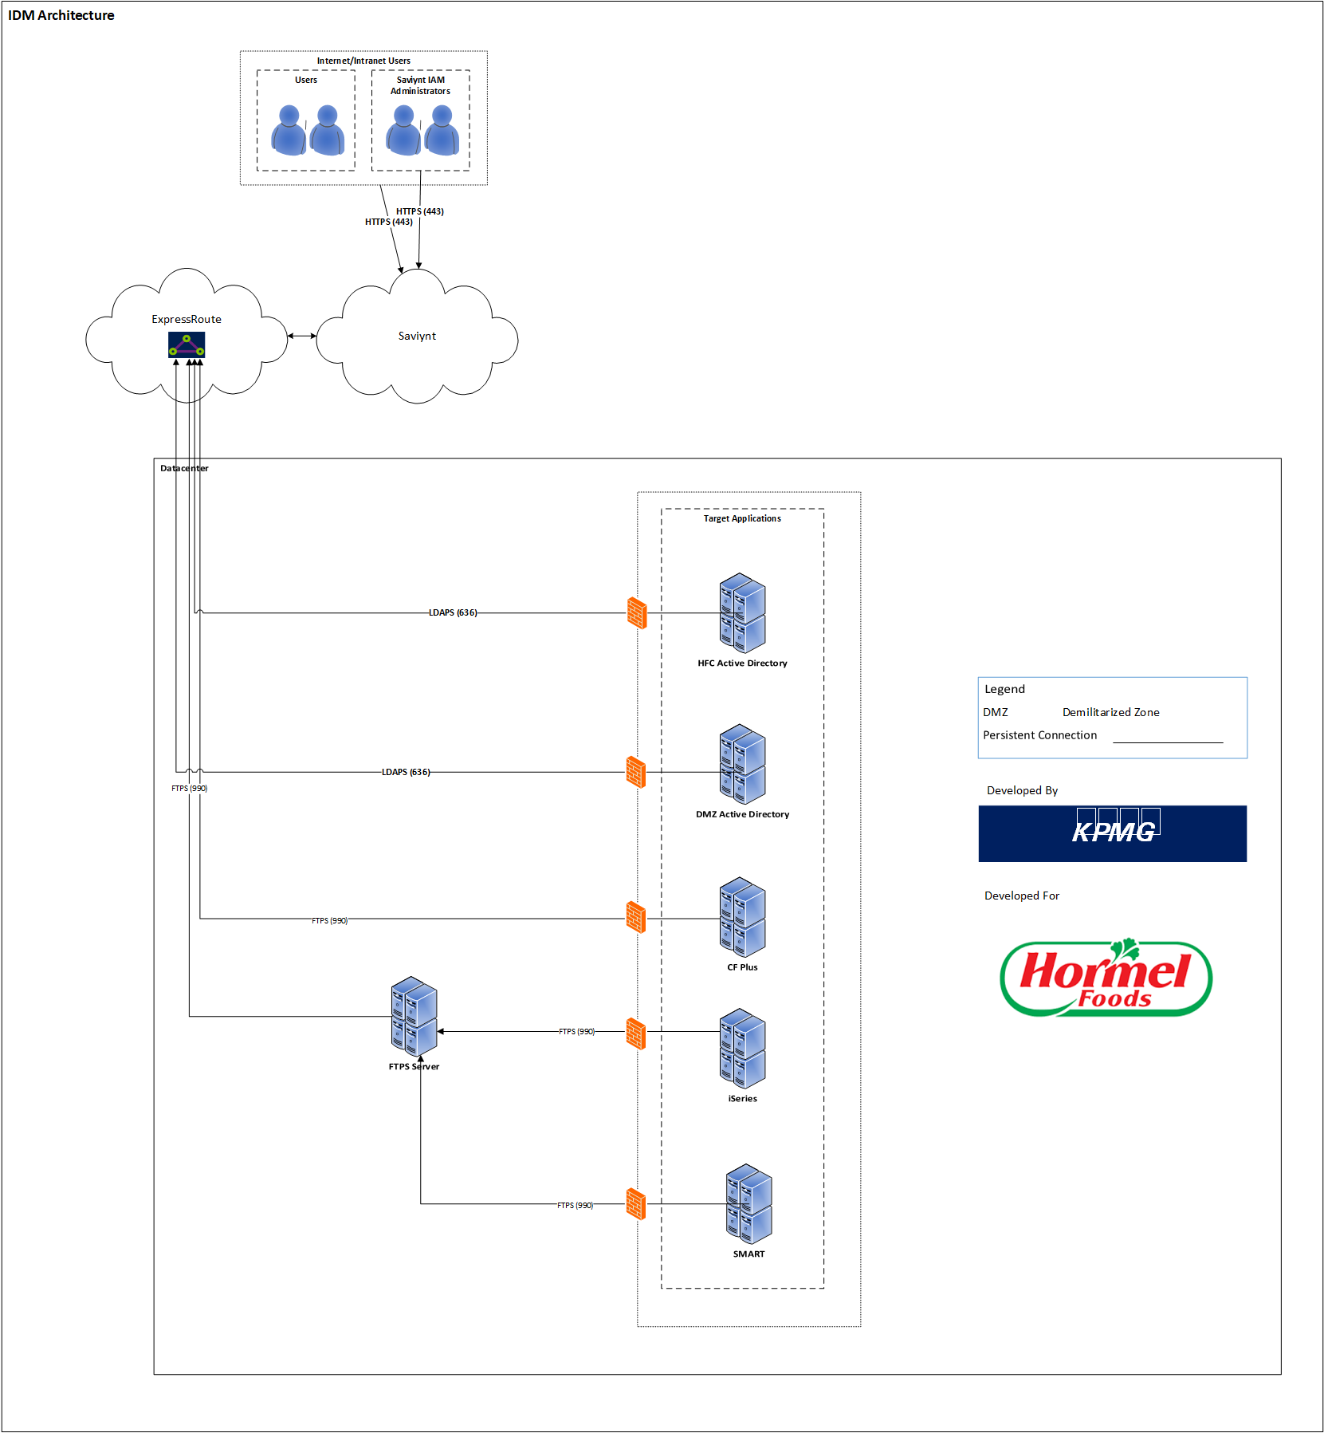
As shown in the diagram above, Saviynt will provide a centralized platform to support identity and access management capabilities, including identity lifecycle and account management for key systems like DMZ Active Directory and Certification campaign for all target application mention in above figure 2. Once deployed, Saviynt will control the provisioning, and de-provisioning of users accounts in the DMZ Active Directory applications. User manager and service account owner campaign will be able to manage from Saviynt.
Table 5: Key Components
Component | Description
SSM | SSM represents the SaaS-based application that is deployed on a public cloud by Saviynt. It is exposed to the enterprise as a web application.  This is the centralized IDM system which will facilitate automated identity onboarding, provisioning, de-provisioning, access request, certifications, and reconciliation functions in the enterprise.
Express Route | SSM uses the express route service that is offered by Azure to route the traffic from Saviynt virtual network to Hormel virtual network.
HFC Active Directory | Existing HFC AD connector will be used to reconcile all account and service account details. Once service account owner are set for campaign will be launched for service account only. User manager campaign will be configured
DMZ Active Directory | As a part of the initial (or Day 0) load, existing accounts will be reconciled into SSM from DMZ AD . For privileged account, account type attribute will be updated as Service or Generic account through CSV file.  DMZ Active Directory would become one of the downstream systems for SSM post go-live.  employeenumber will be correlation for DMZ AD maintenance account. For Service and Generic account owner must be set in Saviynt before launching campaign
CF Plus | Saviynt will be able to connect CF Plus application using Saviynt Database connector. All account and groups will be reconciled into Saviynt. Provision will be not in scope for this phase. User manager campaign will be launched which includes account and entitlement.
iSeries (ASDPT001) | Flat file connection will be used to import all user account and entitlement details. User manager campaign will be launched which includes account and entitlement.  As iSeries (ASDPT001) do not provide any correlation id matching with user profile in Saviynt. In such case Saviynt admin must manually correlate account with user.
SMART | Flat file connection will be used to import all user account and entitlement details. User manager campaign will be launched which includes account and entitlement.

User Experience
This section details the user experience of various Actors when they interact with the SSM web interface while performing various activities that are part of the scope of this design. It is noted that SSM, being a SaaS solution, provides only limited capabilities to customize user experience and the solution design is limited to customizations that are supported on the platform.

Access Requester Experience
In the enterprise, the IDM solution provides a centralized platform for access requests. SSM’s access request system is leveraged for request workflow. SSM enables users to raise access requests for following types of access:
- Application Accounts
The following steps provide additional details on the user experience of a typical request for Application. Note that depending upon request and details provided, the user experience may differ.

Step 1: Users log in to Saviynt Security Manager using their credentials and click on Request Access tile on ARS page.
Figure 3: Request Access
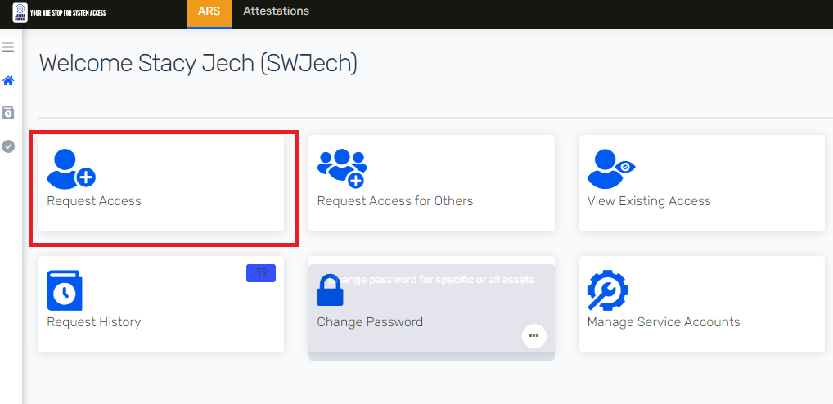
Step 2: Users select the appropriate application to add to the cart and click on the Checkout button.
Figure 4: Add to Cart
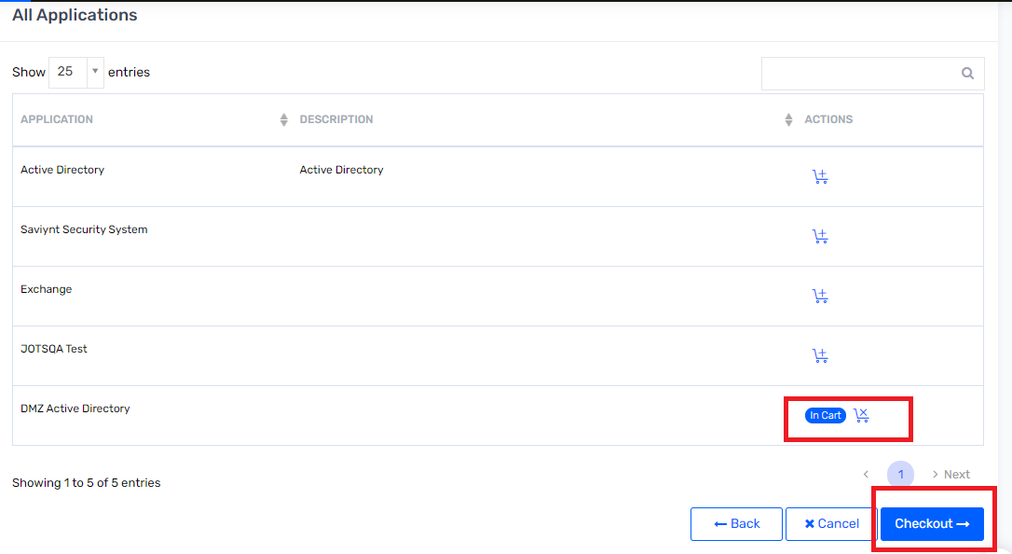
Step 4: Users select click on the Next button.
Figure 5: Select Access
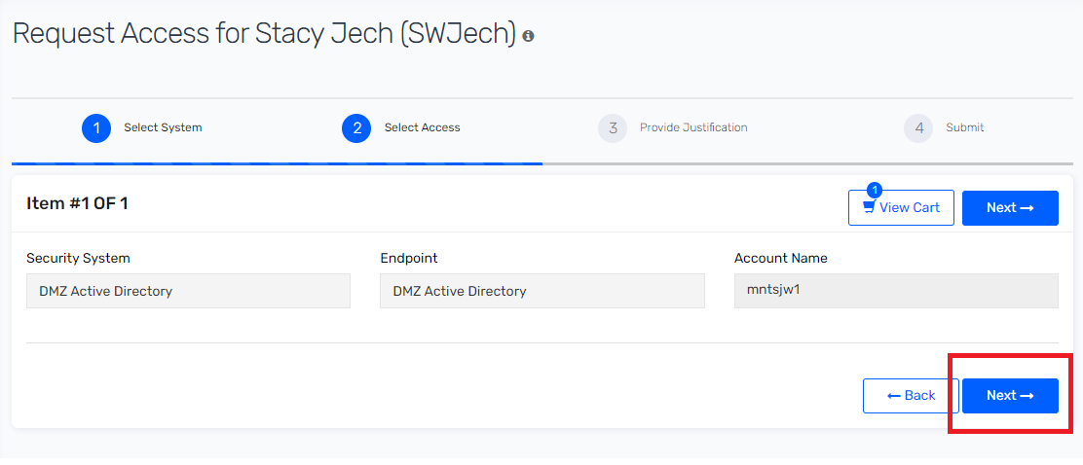
Step 5: Add the Business Justification and Comments then submit the request. Note that these are comments required for the approver to understand the need of request and approve it.
Figure 6: Add Business Justification
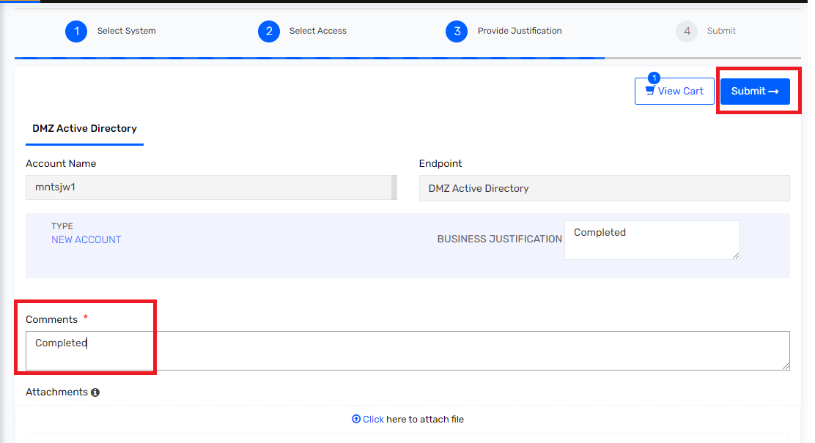

Approver Experience
Step 1: Approver receives an email-based notification once the request is assigned to him/her. Refer to Section 9.2 for details.
Step 2: Approver Logs on to Saviynt and clicks on Request Approval tile or Request Approval tab on the left pane from ARS tab.
Figure 7: Request Approval (tile or tab)
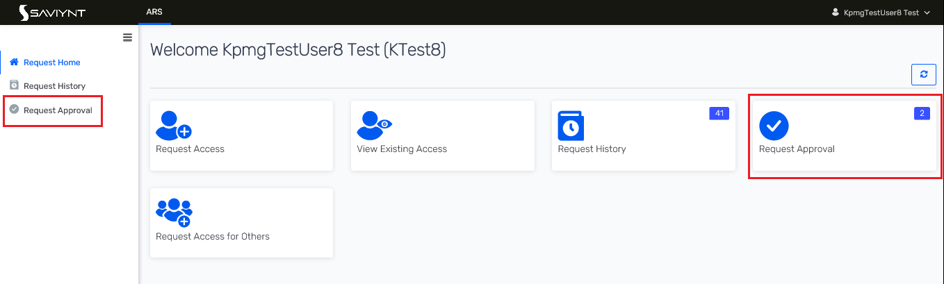
Step 3: Select the Request ID to view the request details.
Figure 8: User Request ID
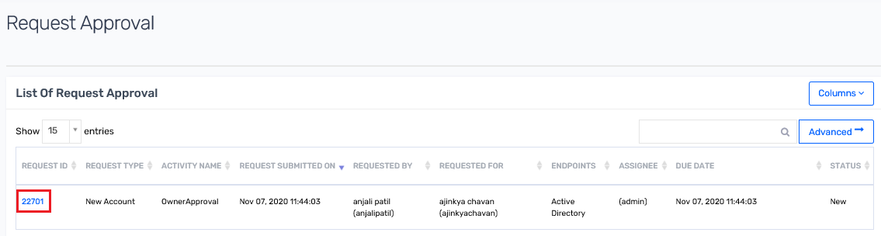

Step 4: View the details of the request and select on Accept or Reject access detail. Note that the Approver will have the ability to “partially” approve a request. By partial approval, approver must make sure that “New Account” is approved to approve at least one “ACCESS” for a request that has account and access request for an endpoint.

Figure 9: Accept/Reject Request
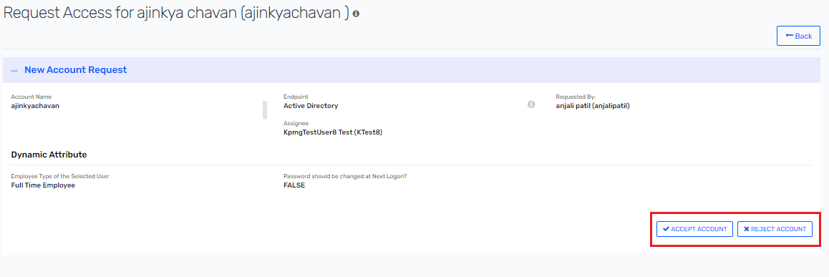

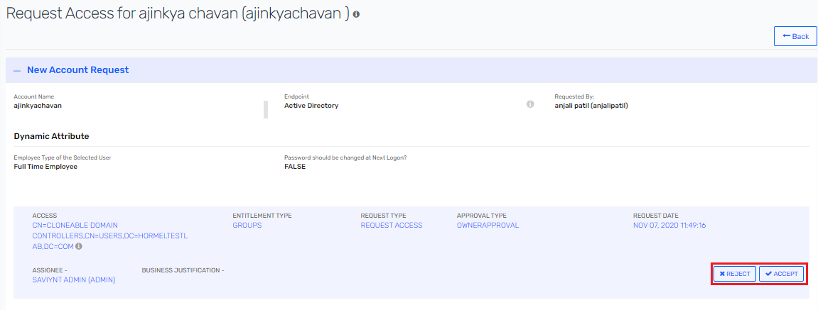

Step 5: Enter the comment and click on submit.
Figure 10: Add Comment and Submit
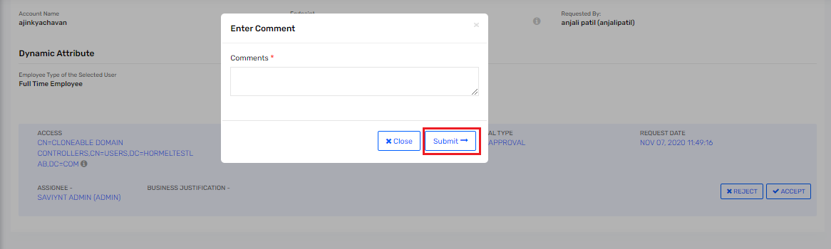

Step 6: Approver confirm the request by clicking on the Confirm button.
Figure 11: Confirm Request
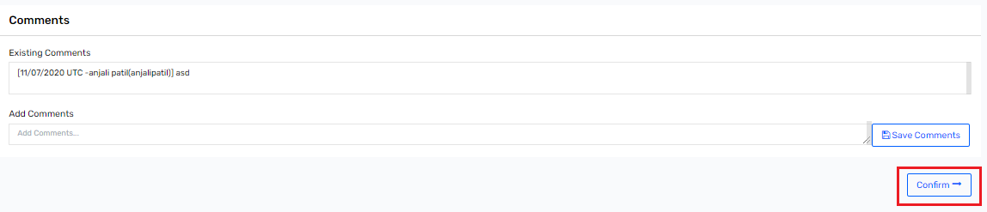

Step 7: Once the request is confirmed, a message will pop on top right of screen as Request completed.
Figure 12: Request Completed
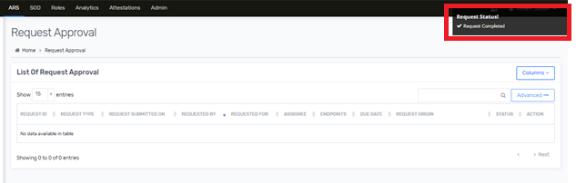

Landing Page Shortcuts
Saviynt supports customizations to bring shortcuts to the landing page of users for easy access. The following shortcuts will be created for various actors.
Table 6: Landing Page Shortcuts
Actor | End-User  (ROLE_HORMEL_ENDUSER)
Request Access
View Existing Access
Request History
Request Approval
Change Password
Request Access for Others
Attestation
Manage Service Account (Only with IT department can raise request for self)

Password Reset

DMZ AD Maintenance Account Password Reset
The following steps provide additional details on the user experience of a typical changing DMZ AD maintenance user account
Step 1 : Login into SSM. Navigate to ARS tab. Select on Change password tile and select “Change Account Password for Self”.
Figure 13 : ARS Page
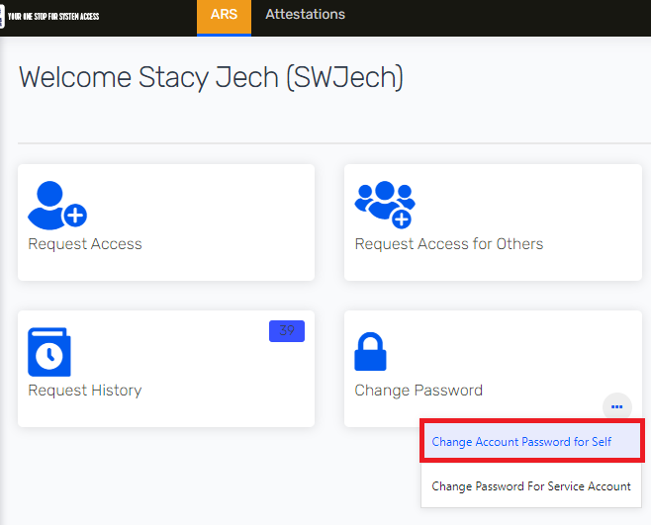
Step 2 : Click on Add to Cart icon.
Figure 14 : Cart
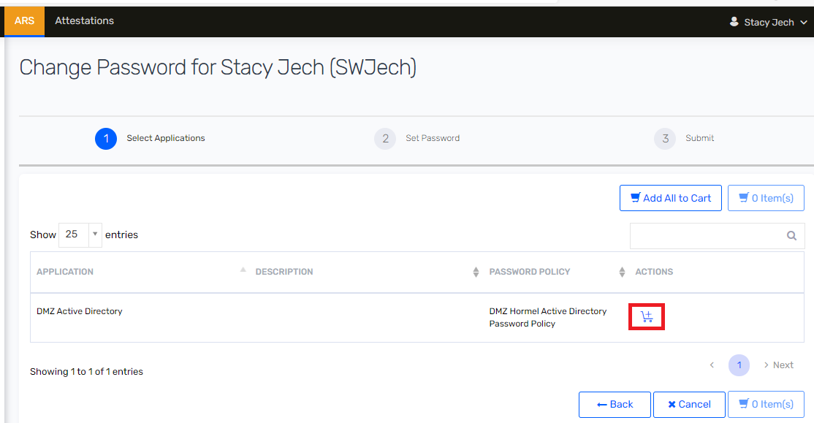

Step 3 : Click on Checkout button.
Figure 15 : Checkout Page
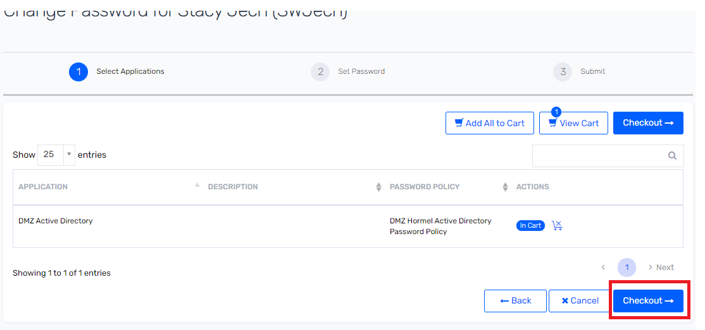

Step 4 : Click on Checkbox and I’m not robot. And then click on Change Password button.

Figure 16 : Change Password
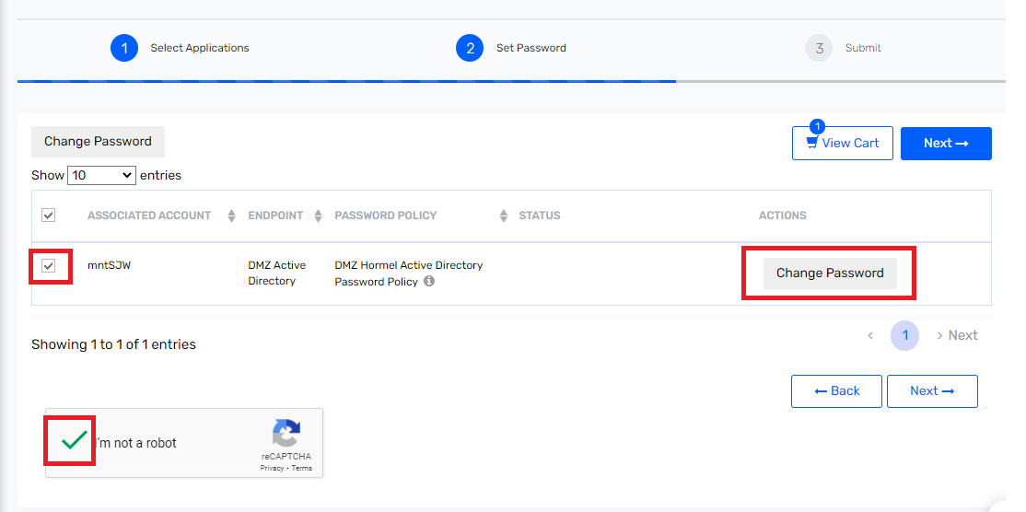
Step 5 : Enter new password and click on Use password button.

Figure 17 : New Password
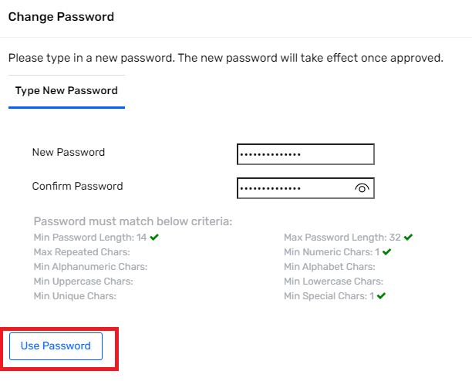
Step 6 : Password changed successfully changed.
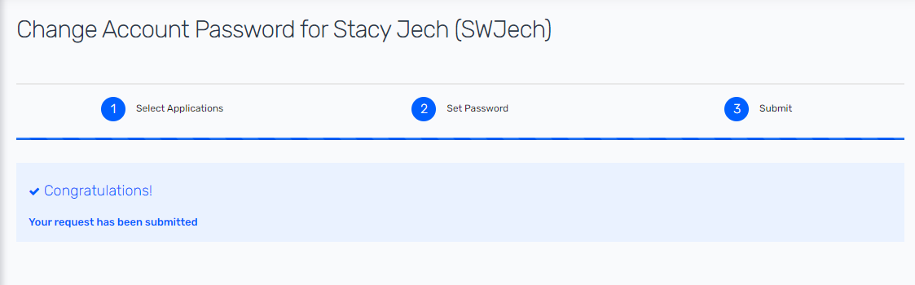

DMZ AD Service Account Password Reset
The following steps provide additional details on the user experience of a typical changing DMZ AD maintenance user account
Step 1 : Login into SSM. Navigate to ARS tab. Select on Change password tile and select “Change Password for Service Account”.
Figure 18 : ARS Tab
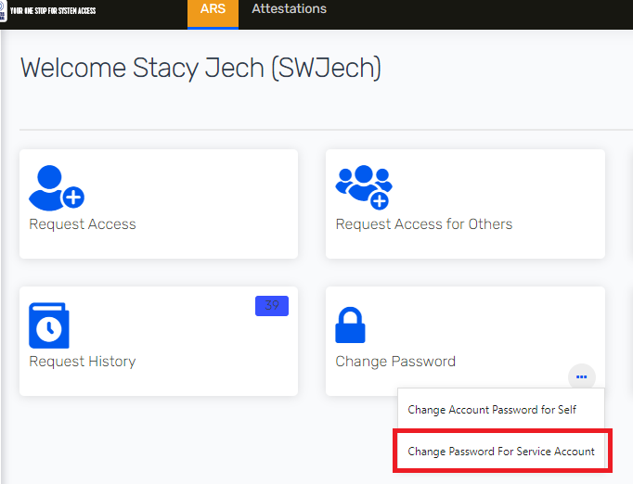
Step 2 : Click on Add to Cart and Checkout button.

Figure 19 : Change Password for Service Account
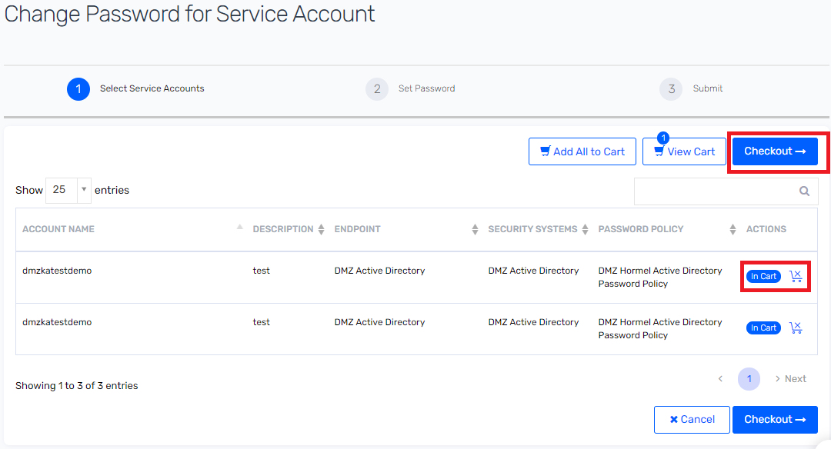
Step 3 : Select Reset password form Actions and Set on new password and click on “Next”.
Figure 20 : Set Password
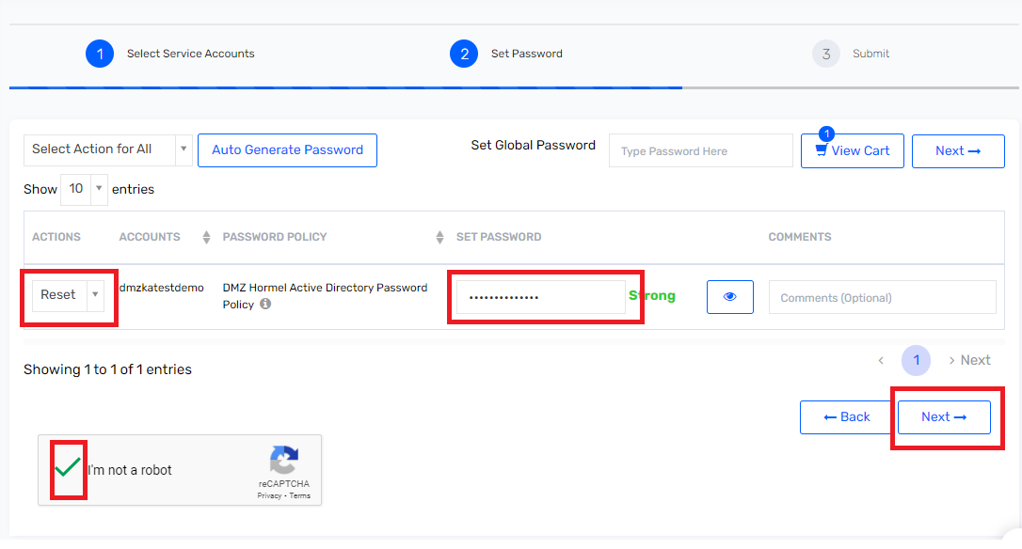
Step 6 : Password changed successfully changed.

Figure 21 : Password Reset Completed
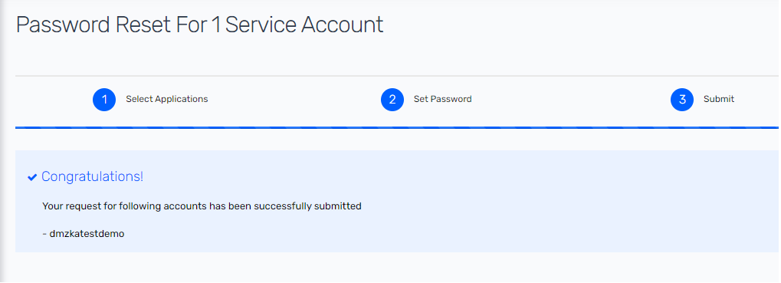

Certification Campaign
Following section provides UI experience of certification campaign for certifier.
Step 1: Login into SSM. Click on Attestation tab. Click on latest launch campaign by click on campaign name.
Figure 22 : Attestation
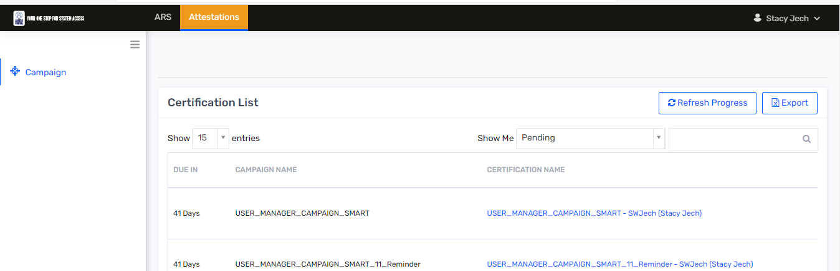

Step 2: Click on checkbox and select appropriate employment status such as “Work for me” or “Does not work for me”. Then click on Next.
Figure 23 : Employment verification
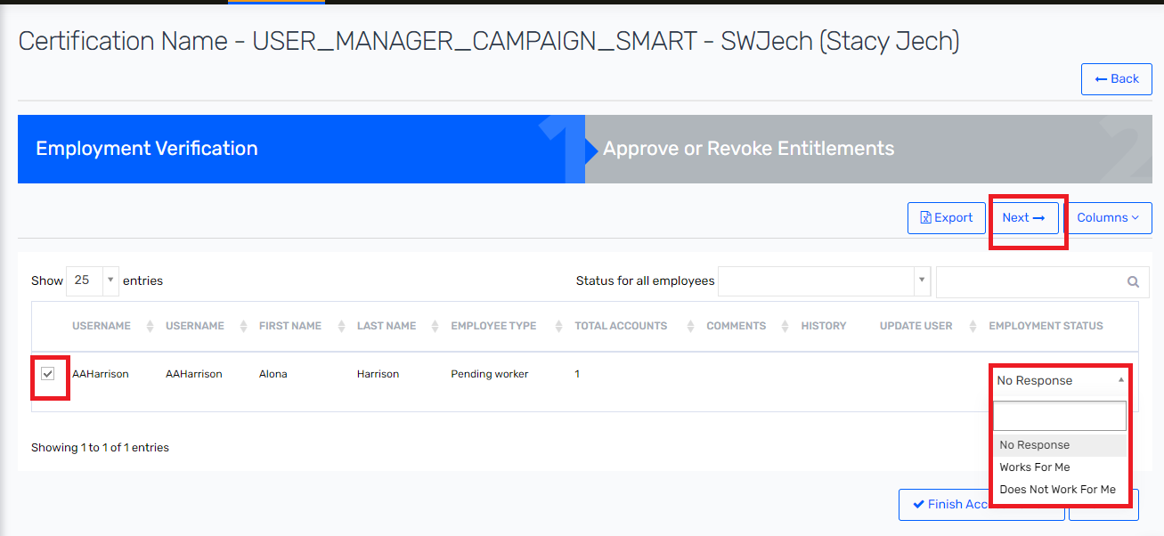

Step 3 : Review access and select appropriate action on Account and Entitlement such as Certify or revoke access for user and click on Finish Review.
Figure 24 : Access Verification
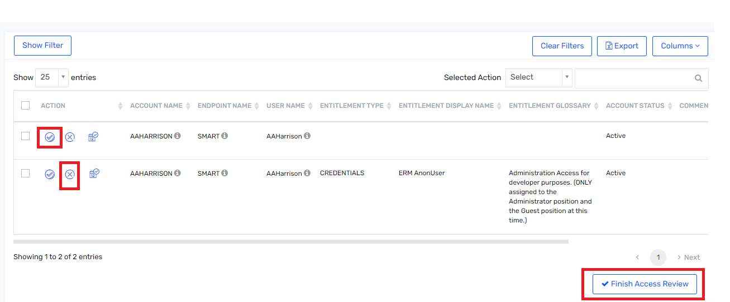
Step 4 : Review Certification summary. And enter comment and click on Yes button.
Figure 25 : Certification completed
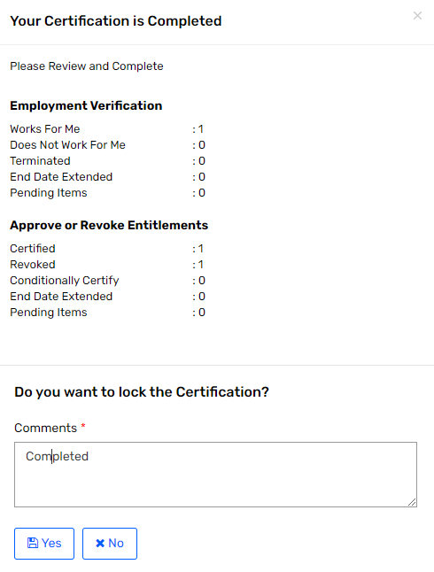

Logical Design

Naming Conventions
Following naming conventions would be used while defining various artefacts within SSM.
Table 7: Naming Convention
Configuration Type | Naming Convention | Sample
Application Names | Generic name of Applications as they are known in Hormel | Active Directory  DMZ Active Directory  CF Plus
Workflow Names | Capitalization, the first letter of a word in uppercase, and the rest of the letters in lowercase or called Camel Case. | Account Group Approval Workflow
Custom Attribute Names | Capitalization, the first letter of a word in uppercase, and the rest of the letters in lowercase or called Camel Case. | Description
Schedule Task Names | ALL CAPS, all letters in every word are capitalized. | PROVISIONING_JOB  HORMEL_USER_RECON
Application Entitlements | As defined in downstream systems. | NAMEDUSER_NO_RDP
Campaign Name | ALL CAPS, all letters in every word are capitalized. | USER_MANAGER_CAMPIAGN_(application name)

Applications
Following applications will be defined on SSM
Table 8: Application List
Application Name | Description | Attestation | Provisioning Support | Reconciliation Support | Connector(s)
HFC Active Directory | Downstream system | Yes  User Account  Service Account | Yes | Yes | AD
DMZ Active Directory | Downstream system | Yes  User Account  Service Account | Yes | Yes | AD
iSeries (ASDPT001) | Target Reconciliation | Yes  User Account and Entitlement | No | Yes | Flat File based Import Job
CF PLUS | Target Reconciliation | Yes  User Account and Entitlement | No | Yes | Flat File based Import Job
SMART | Target Reconciliation | Yes  User Account and Entitlement | No | Yes | Flat File connector

Note: Target Reconciliation means that Saviynt will attempt to co-relate accounts from the source with existing identities, and not create a new identity.

HFC Active Directory Connector Design

User Account Correlation Rule
Users present in Saviynt will be correlated to HFC Active Directory account using below correlation rule.
Table 9 : Active Directory Correlation Rule
Sr No | Saviynt User Attribute Name | Relation | Active Directory Attribute Name
1 | UserName | Equals | sAMAccountName

Reconciliation Attribute Mapping
Table 10 : HFC AD Reconciliation Attribute Mapping
Sr No | Saviynt Account Attribute Name | Saviynt Account Attribute Label | Active Directory Attribute Name | Data Type
1 | LASTLOGONDATE | LASTLOGONDATE | lastLogon | millisec
2 | DISPLAYNAME | DISPLAYNAME | displayName | String
3 | COMMENTS | COMMENTS | distinguishedName | String
4 | LASTPASSWORDCHANGE | LASTPASSWORDCHANGE | pwdLastSet | millisec
5 | DESCRIPTION | DESCRIPTION | description | String
6 | VALIDTHROUGH | VALIDTHROUGH | accountExpires | millisec
7 | UPDATEDATE | UPDATEDATE | whenChanged | String
8 | NAME | NAME | sAMAccountName | String
9 | CREATED_ON | CREATED_ON | whenCreated | String
10 | ACCOUNTCLASS | ACCOUNTCLASS | objectClass | String
11 | ACCOUNTID | ACCOUNTID | distinguishedName | String
12 | STATUS | STATUS | userAccountControl | number
13 | CUSTOMPROPERTY1 | Name | name | String
14 | CUSTOMPROPERTY2 | First Name | givenName | String
15 | CUSTOMPROPERTY3 | Middle Name | initials | String
16 | CUSTOMPROPERTY4 | Last Name | sn | String
17 | CUSTOMPROPERTY5 | Manager | manager | String
18 | CUSTOMPROPERTY6 | User Principal Name | userPrincipalName | String
19 | CUSTOMPROPERTY7 | Title | title | String
20 | CUSTOMPROPERTY8 | Employee Number | employeeNumber | String
21 | CUSTOMPROPERTY9 | Employee ID | employeeID | String
22 | CUSTOMPROPERTY10 | Employee Type | employeeType | String
23 | CUSTOMPROPERTY11 | Department | department | String
24 | CUSTOMPROPERTY12 | Physical Delivery Office Name | physicalDeliveryOfficeName | String
25 | CUSTOMPROPERTY13 | State | st | String
26 | CUSTOMPROPERTY14 | Street Address | streetAddress | String
27 | CUSTOMPROPERTY15 | Country | c | String
28 | CUSTOMPROPERTY16 | City | l | String
29 | CUSTOMPROPERTY17 | Postal Code | postalCode | String
30 | CUSTOMPROPERTY18 | Company | company | String
31 | CUSTOMPROPERTY19 | Mail | mail | String
32 | CUSTOMPROPERTY20 | User Account Control | userAccountControl | String
33 | CUSTOMPROPERTY21 | Object GUID | objectGUID | Binary
34 | CUSTOMPROPERTY22 | Home Directory | HomeDirectory | String
35 | CUSTOMPROPERTY23 | Office | office | String
36 | CUSTOMPROPERTY24 | Extension Attribute 1 | extensionAtrribute1 | String
37 | CUSTOMPROPERTY25 | Target Address | targetAddress | String
38 | CUSTOMPROPERTY26 | External OU |  | String

Update Service account Type
Following section describe an approach to updating account type for HFC AD service account.
In Saviynt an internal job will configure to calculate Service account type based on below OU that account is present in HFC AD.
Table 11 : Service Account Type
Sr No | HFC AD OU | Account type
1 | '%OU=Generic Accounts%'  '%OU=ICA Generic Accounts%'  '%OU=PlantUsers,OU=JOTS%'  '%OU=Ivanti,OU=Exchange%'  '%OU=Restricted,OU=Users%'  '%OU=Departmental Units,OU=Users,OU=JOTS%'  '%OU=Farms,OU=Users,OU=JOTS%'  '%OU=GenericUsersMailEnabled,OU=Users,OU=JOTS%'  '%OU=NVR,OU=Users,OU=JOTS%'  '%OU=PCAutoLockTesting,OU=Users,OU=JOTS%'  '%OU=Plant accounts,OU=Users,OU=JOTS%'  '%OU=Vendors,OU=Users,OU=JOTS%' | Generic Account
2 | '%OU=Service Accounts%'  '%OU=O365_Service-Accounts%' | Service Account

DMZ Active Directory Connector Design

User Account Correlation Rule
Users present in Saviynt will be correlated to DMZ Active Directory account using below correlation rule.
Table 12 : DMZ Active Directory Correlation Rule
Sr No | Saviynt User Attribute Name | Relation | Active Directory Attribute Name
1 | employeeid | Equals | employeenuber

Provisioning Attribute Mapping
Table 13 : DMZ AD Provisioning Attribute Mapping
Sr No | Saviynt Attribute Name | Active Directory Attribute Name | Required for Create JSON? | Required for Update JSON? | Any Transformation
1 | accountName | sAMAccountName | Yes | No
2 | employeeNumber | employeeNumber | Yes | No | If account is Service/generic, this attribute will be set to empty  If account is Maintenance then attribute is set to user’s employeenumber
3 | accountName | givenName | Yes | No
4 | accountName | UserPrincipalName | Yes | No | accountName@ HRLDMZ.DMZ
5 | accountName | displayname | Yes | No
6 | Description | description | Yes | No | If user request service/generic account through request form, then set value present of description into DMZ AD account description attribute.  If account is Maintenance account set as “systemUserName DMZ Maintenance User”
7 |  | pwdLastSet | Yes | No | If account is maintenance or service or generic account set pwdLastSet as ‘0’
8 | statuskey | userAccountControl | Yes | No | If Service/generic account , then set following status  Active: 66048  Inactive: 514  If Maintenance account, then set following status  Active: 512  Inactive: 514
9 |  | cn/dn | Yes | No | accountName,OU=Default-IAM-Users,DC=HRLDMZ,DC=DMZ

Reconciliation Attribute Mapping
Table 14 : DMZ AD Reconciliation Attribute Mapping
Sr No | Saviynt Account Attribute Name | Saviynt Account Attribute Label | Active Directory Attribute Name | Data Type
1 | LASTLOGONDATE | LASTLOGONDATE | lastLogon | millisec
2 | DISPLAYNAME | DISPLAYNAME | displayName | String
3 | COMMENTS | COMMENTS | distinguishedName | String
4 | LASTPASSWORDCHANGE | LASTPASSWORDCHANGE | pwdLastSet | millisec
5 | DESCRIPTION | DESCRIPTION | description | String
6 | VALIDTHROUGH | VALIDTHROUGH | accountExpires | millisec
7 | UPDATEDATE | UPDATEDATE | whenChanged | String
8 | NAME | NAME | sAMAccountName | String
9 | CREATED_ON | CREATED_ON | whenCreated | String
10 | ACCOUNTCLASS | ACCOUNTCLASS | objectClass | String
11 | ACCOUNTID | ACCOUNTID | distinguishedName | String
12 | STATUS | STATUS | userAccountControl | number
13 | CUSTOMPROPERTY1 | When Changed | whenChanged | String
14 | CUSTOMPROPERTY2 | First Name | givenName | String
15 | CUSTOMPROPERTY3 | Middle Name | initials | String
16 | CUSTOMPROPERTY4 | Last Name | sn | String
17 | CUSTOMPROPERTY5 | Manager | manager | String
18 | CUSTOMPROPERTY6 | User Principal Name | userPrincipalName | String
19 | CUSTOMPROPERTY7 | Title | title | String
20 | CUSTOMPROPERTY8 | Employee Number | employeeNumber | String
21 | CUSTOMPROPERTY9 | Employee ID | employeeID | String
22 | CUSTOMPROPERTY10 | Employee Type | employeeType | String
23 | CUSTOMPROPERTY11 | Department | department | String
24 | CUSTOMPROPERTY12 | Physical Delivery Office Name | physicalDeliveryOfficeName | String
25 | CUSTOMPROPERTY13 | State | st | String
26 | CUSTOMPROPERTY14 | Street Address | streetAddress | String
27 | CUSTOMPROPERTY15 | Country | c | String
28 | CUSTOMPROPERTY16 | City | l | String
29 | CUSTOMPROPERTY17 | Postal Code | postalCode | String
30 | CUSTOMPROPERTY18 | Company | company | String
31 | CUSTOMPROPERTY19 | Mail | mail | String
32 | CUSTOMPROPERTY20 | User Account Control | userAccountControl | String
33 | CUSTOMPROPERTY21 | Object GUID | objectGUID | Binary
34 | CUSTOMPROPERTY22 | Home Directory | HomeDirectory | String
35 | CUSTOMPROPERTY23 | Office | office | String
36 | CUSTOMPROPERTY24 | Extension Attribute 1 | extensionAtrribute1 | String
37 | CUSTOMPROPERTY25 | Target Address | targetAddress | String

DMZ Active Directory Maintenance Account Creation
DMZ AD maintenance account is only through requestable. User with department as “IT” will be only able to request DMZ Active Directory account.
The creation of an DMZ AD Account is depicted in the workflow:
Figure 26: DMZ AD Account Creation
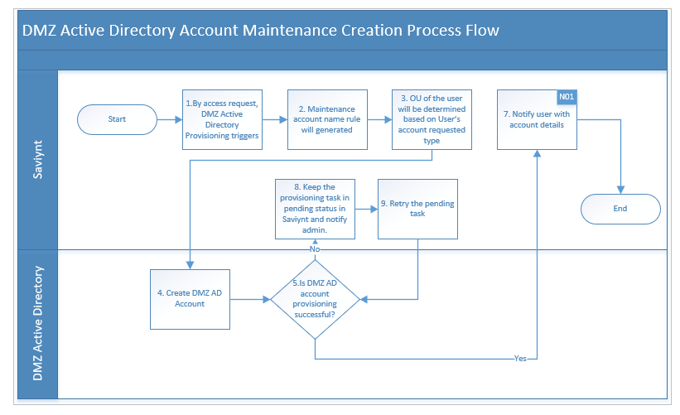
Description:
The following actions take place when a new DMZ AD Maintenance Account is created by Saviynt:
- Pre-populate attributes like accountname , employeeNumber, givenName, displayname etc. have a one to one mapping with the fields on the Saviynt profile.
- Saviynt creates maintenance account with following rule:-
  - mnt+firstname (1st character )+ middlename (1st character)+lastname (1st character) + autoincrement (if already accountname exists)
- Compute and pre-populate the attribute based on attribute list given in Provisioning Attribute Mapping.
- User dn will be generated based on the user’s “HRLDMZ-Users-MaintenanceAccount OU”.
- A notification is sent to the user about the successful creation of the AD account for the user with the following details:
- User Name
- Instruction to reset password fom Saviynt
- If the AD account creation is unsuccessful then the failed task report will be sent to Security Tech team with failed task details.

DMZ Active Directory Service Account Creation
DMZ AD Service and Generic account is only through requestable. User with department as “IT” will be only able to request DMZ Active Directory account.
The creation of an DMZ AD Service Account is depicted in the workflow:
Figure 27: DMZ AD Service and Generic Account Creation
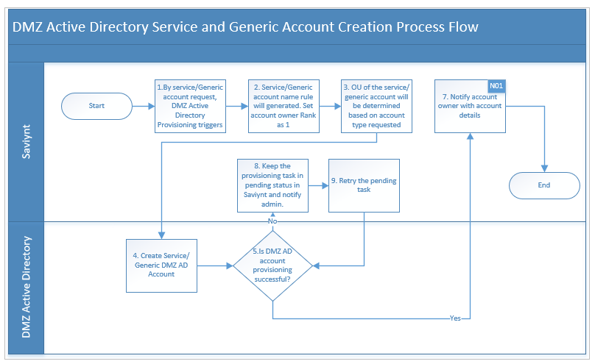
Description:
The following actions take place when a new DMZ AD Maintenance Account is created by Saviynt:
- Service/Generic account is requestable through manage service account.
- Account owner enters account name respective function.
- Saviynt creates Service account with following rule:-
  - mrdmz+(whatever function name).
- Saviynt creates Generic account with following rule:-
  - dmz+(whatever function name).
- Account owner enters description and limit for description is 130 characters
- Compute and pre-populate the attribute based on attribute list given in Provisioning Attribute Mapping.
- User dn will be generated based on the accounttype requested “HRLDMZ-Users-GenericAccounts OU” or HRLDMZ-Users-ServiceAccounts OU
- A notification is sent to the user about the successful creation of the AD account for the user with the following details:
- User Name
- Instruction to reset password fom Saviynt
- If the AD account creation is unsuccessful then the failed task report will be sent to Security Tech team with failed task details.

DMZ Active Directory Account Disable
The user’s Saviynt profile is disabled as a result of termination sent by HCM to Saviynt during an identity reconciliation run. In such event active DMZ AD maintenance account will be marked as disabled, account will be moved to TBD OU. User will not be able to remove account through request base.
The flow of account disable is depicted in the following workflow:
Figure 28: DMZ AD Maintenance Account Disable
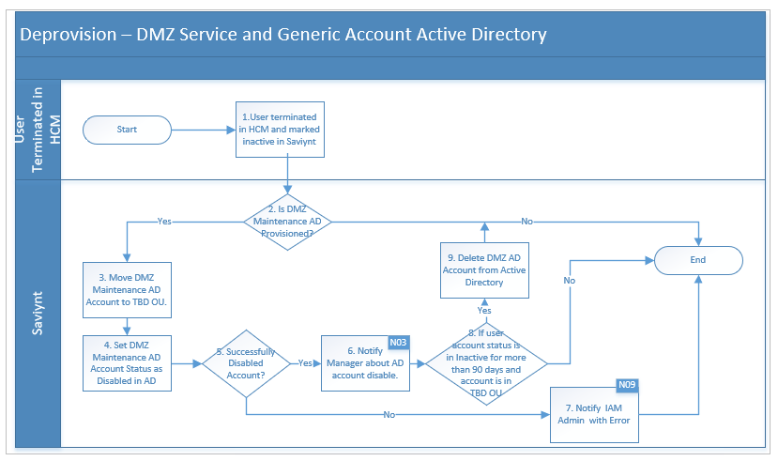
Description:
As a result of a user termination/disable,
- The user’s Saviynt profile will be disabled.
- As a result of the Saviynt profile being disabled, Saviynt disables the user’s DMZ AD maintenance account.
- DMZ AD maintenance account of the user will be moved to TBD OU. Security groups will be not removed from Saviynt.
- DMZ AD maintenance account expiry date will be set as date of disable.
- The user’s AD maintenance account is not deleted as such but rather disabled on the target system and the corresponding account in Saviynt shows up as ‘Disabled’.
- Manager will receive the DMZ AD maintenance account disable success email for the user.

DMZ Active Directory Account Deletion
The user’s Saviynt profile and AD account is disabled for more than 90 days and AD account of the user will be permanently deleted from AD.
The flow of account deletion is depicted in the following workflow:
Figure 29: DMZ AD Maintenance Account Deletion
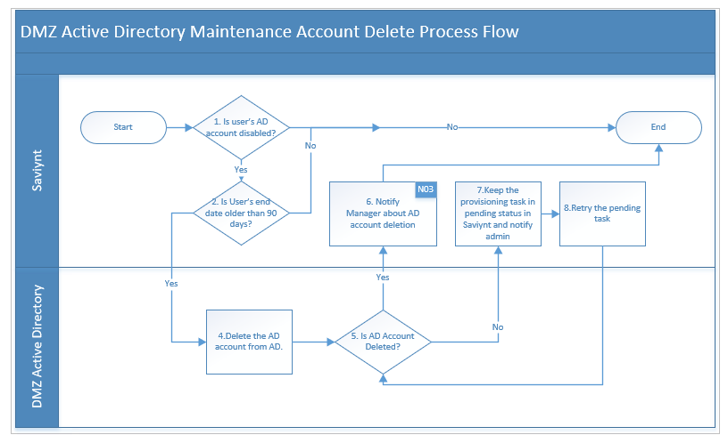
Description:
As a result of a user AD account deletion,
- The user’s Saviynt profile is disabled for more than 90 days.
- User’s AD account is present in TBD OU, then AD account will be deleted permanently by Saviynt.
- Manager will receive the AD account termination success email for the user.

DMZ Active Directory Account Rehire
When a user is rehired after the termination in HCM then AD account needs to be re-enabled in Saviynt.
The flow of account enable/rehire is depicted in the following workflow:
Figure 30: DMZ AD Maintenance Account Rehire
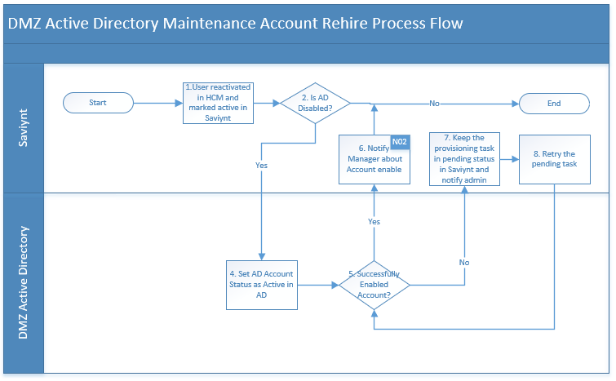
Description:
The following actions take place when a user re-hired after the termination:
- If user has the disabled DMZ AD account, then that account gets enabled.
- DMZ AD maintenance account will be moved to Maintenance accounts based OU in DMZ AD.
- Manager will receive the AD account enable success email for the user.

iSeries (ASDPT001) Connector Design
iSeries(ASDPT001) will disconnected application. iSeries application files are generated by application team and stored on SFTP server. Saviynt will fetch account and entitlement csv file from SFTP server which is deployed in Hormel on premises.

User Account Correlation
For iSeries application we do not have any unique attribute that matches to user profile in Saviynt. So, in this case account need to be manually correlated or through csv load.
Orphan account report will be generated to analyse such account easily.

Reconciliation Attribute Mapping
Users present in Saviynt will be correlated to SMART account using below correlation rule.
Table 15 : Account Reconciliation Attribute Mapping
Sr No | Saviynt Account Attribute Name | Saviynt Account Attribute Label | Application csv file header
1 | ACCOUNTID | ACCOUNTID | ACCOUNTID
2 | ENDPOINTNAME | NA | ENDPOINTNAME
3 | ACCOUNTNAME | Name | ACCOUNTNAME
4 | DISPLAYNAME | DISPLAYNAME | DISPLAYNAME
5 | CREDENTIALS | NA | CREDENTIALS
6 | STATUS | STATUS | STATUS

Table 16 : Entitlement Reconciliation Attribute Mapping
Sr No | Saviynt Account Attribute Name | Application csv file header
1 | securitysystems | ACCOUNTID
2 | endpoints | ENDPOINTNAME
3 | entitlement_value | ACCOUNTNAME
4 | entitlementtype | entitlementtype
5 | displayname | displayname

SMART Connector Design
SMART will be a disconnected application. SMART application files are generated by application team and stored on SFTP server. Saviynt will fetch account and entitlement csv file from SFTP server which is deployed in Hormel on premises.

User Account Correlation Rule
Users present in Saviynt will be correlated to SMART account using below correlation rule.
Table 17 : SMART Correlation Rule
Sr No | Saviynt User Attribute Name | Relation | Active Directory Attribute Name
1 | UserName | Equals | ACCOUNTNAME

Reconciliation Attribute Mapping
Users account attributes will be updated with the reconciliation attributes after import is done from csv load.
Table 18 : Account Reconciliation Attribute Mapping
Sr No | Saviynt Account Attribute Name | Saviynt Account Attribute Label | Application csv file header
1 | ACCOUNTID | ACCOUNTID | ACCOUNTID
2 | ENDPOINTNAME | NA | ENDPOINTNAME
3 | ACCOUNTNAME | Name | ACCOUNTNAME
4 | DISPLAYNAME | DISPLAYNAME | DISPLAYNAME
5 | CREDENTIALS | N/A | CREDENTIALS
6 | STATUS | STATUS | STATUS

Table 19 : Entitlement Reconciliation Attribute Mapping
Sr No | Saviynt Account Attribute Name | Application csv file header
1 | securitysystems | ACCOUNTID
2 | endpoints | ENDPOINTNAME
3 | entitlement_value | ACCOUNTNAME
4 | entitlementtype | entitlementtype
5 | displayname | displayname

CF PLUS Connector Design
CF Plus will connected application. Saviynt will use DB connector to connect CF Plus application to fetch all accounts and entitlements Correlation Rule

User Correlation Rule
Users present in Saviynt will be correlated to CF Plus account using below correlation rule.
Table 20 : Active Directory Correlation Rule
Sr No | Saviynt User Attribute Name | Relation | CF Plus Attribute Name
1 | UserName | Equals | Accountname

Reconciliation Attribute Mapping
Users account attributes will be updated with the reconciliation attributes that are populated after user account reconciliation.
Table 21 : CF Plus Account Reconciliation Attribute Mapping
Sr No | Saviynt Account Attribute Name | Saviynt Account Attribute Label | CF PLUS Attribute Name | Data Type
1 | systemname | N/A | “CF Plus” (Hard coded) | character
2 | endpointname | N/A | “CF Plus” (Hard coded) | character
3 | name | Name | SAMACCOUNTNAME | character
4 | accountid | USERID | USERID | number
5 | status | Status | INACTIVE_DATE | number
6 | displayname | Display name | FIRST_NAME LAST_NAME | character
7 | customproperty1 | First name | FIRST_NAME | character
8 | Customproperty2 | Middle Name | MI | character
9 | Customproperty3 | Last Name | LAST_NAME | character
10 | Customproperty4 | Email | EMAIL | character
11 | Customproperty5 | Emp_Id | EMP_ID | character
12 | Customproperty6 | Active Date | ACTIVE_DATE | Date
13 | Customproperty7 | Inactive Date | INACTIVE_DATE | Date
14 | entitlementname | N/A | CREDENTIALS (Hard coded) | character
15 | entitlementvalue | N/A | ENTITLEMENT_VALUE | character

Table 22 : CF Plus Entitlement Reconciliation Attribute Mapping
Sr No | Saviynt Account Attribute Name | CF PLUS Attribute Name | Data Type
1 | systemname | “CF Plus” (Hard coded) | character
2 | endpointname | “CF Plus” (Hard coded) | character
3 | entitlementname | CREDENTIALS (Hard coded) | character
4 | entitlementvalue | ENTITLEMENT_VALUE | character
5 | description | GROUP_DESC | number
6 | entitlement_glossary | GROUP_INFO | character
7 | displayname | GROUP_DESC | character
8 | customproperty1 | APPLICATION_ID | character
9 | Customproperty2 | APP_NAME | character
10 | Customproperty3 | GROUP_ID | character
11 | status | '1' (Hard coded) | character

User Manager Certification
User Manager certification campaign helps to ensure the managers are aware of their reportees and their respective accesses to entitlements and accounts. The User Manager campaign allows you to launch the campaign for the selected set of certifiers or all certifiers.
User Manager campaign allows the certifiers to verify the employment status of the reportees to check if they are direct reportee or not, by selecting the following options:
- Works for Me : If certifier selects “work for me” option then certifier has ability to Certify or Revoke user account/ access.
- Does not work for me : If certifier is not sure about reportee access and they select “Does not work for me” then that account and access will be reassigned to “Campaign owner”.

Figure 31 : User Manager Campaign
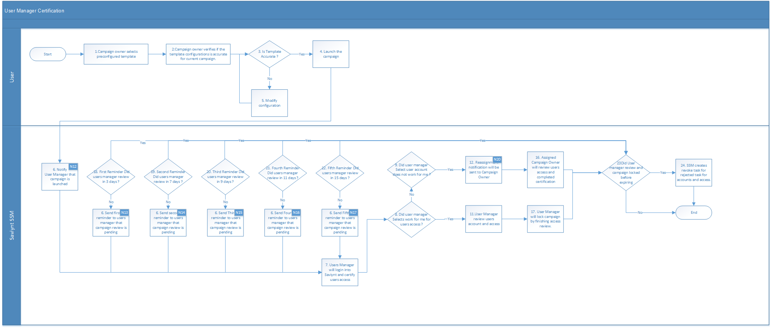
Description:
The following actions take place when a certifier perform action in certification campaign
- When campaign owner launch user manager campaign. Individual campaign certifier will receive notification.
- Certifier will login into the campaign and select the user manager campaign.
- Certifier will review employment verification whether it belongs to them or not. If certifier select “Does not work for me“ option then a certifier will get a popup for reassignment. Certifier can select the user shown in the list for reassignment. Campaign owner will receive email about reassignment.
- If certifier selects “work for me” option then certifier has ability to Certify or Revoke user account/ access.
- Based on action certifier performs access to account or entitlement will be retain or revoked.
- In case certifier do not perform any action then recurring reminder will be sent to certifier review access.

Service Account Owner Certification
The Service account campaign allows you to certify the users who have ownership of service accounts. A service account is an account in SSM with privileged access to critical accounts.
To launch service account owner campaign following process shows that primary certifier need to set before launching campaign.
Figure 32 :Set Primary Certifier for Service Account Owner Campaign
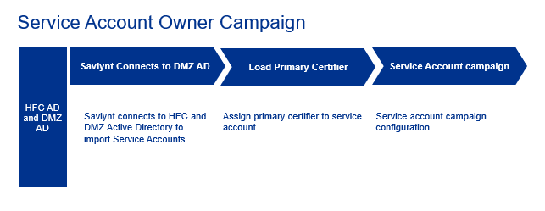
Service account owner campaign allows the certifiers to verify the ownership on their access. Following option owner can perform on Owner verification.
- Works for Me : If certifier selects “work for me” option then certifier has ability to Certify or Revoke their account/ access.
- Does not work for me : If certifier is not sure about their access and they select “Does not work for me” then that account and access will be reassigned to selected user and ownership for that account will be transferred once reassignment user locks the campaign.
Figure 33 : Service Account Owner Campaign
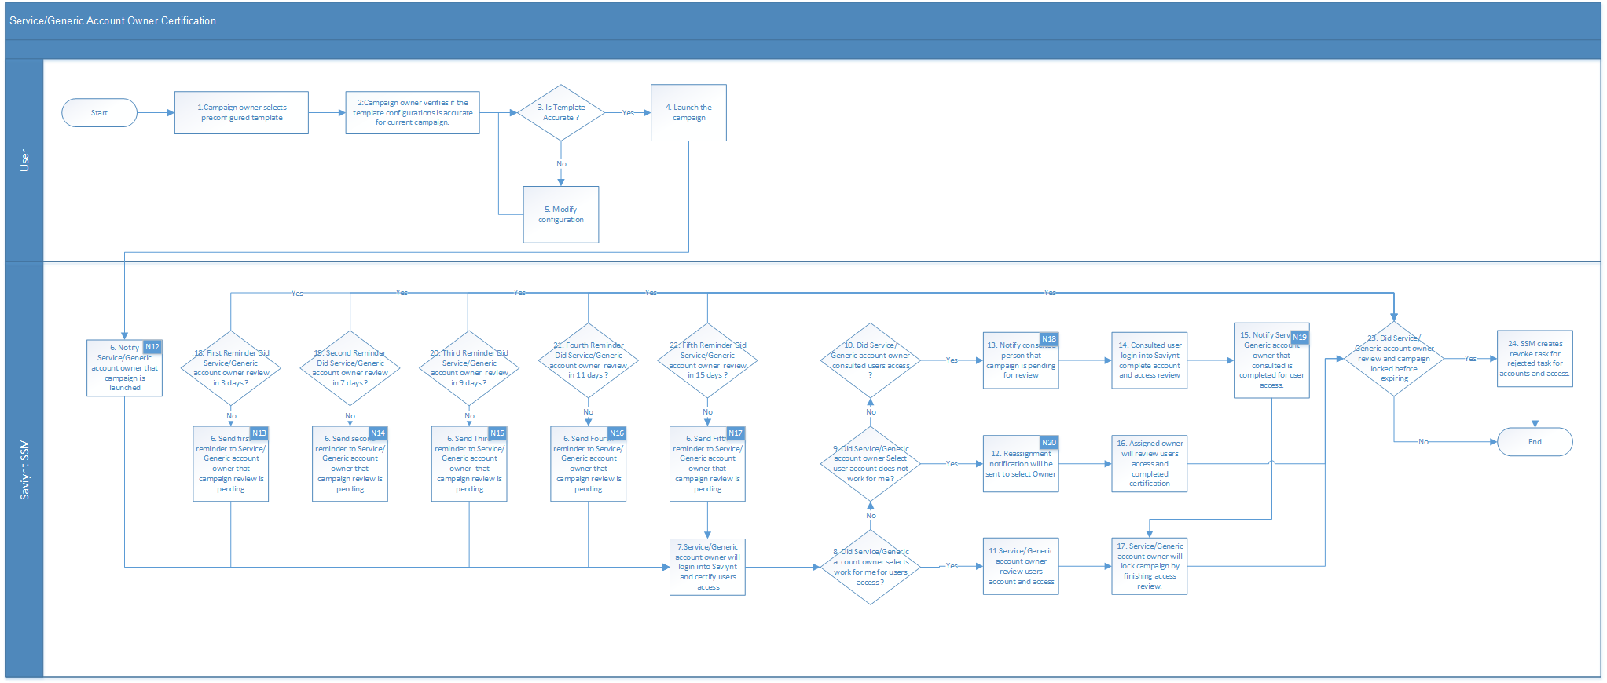
Description:
The following actions take place when a certifier perform action in certification campaign
- When campaign owner launch user manager campaign. Individual campaign certifier will receive notification.
- Certifier will login into the campaign and select the Service account owner campaign.
- Certifier will review Owner verification whether it belongs to them or not. If certifier select “Does not work for me“ option then a certifier will get a popup for reassignment. Certifier can select the user shown in the list for reassignment.
- Once reassignment is completed original certifier will not be able to see any task in this queue. Campaign owner will receive email about reassignment.
- If certifier selects “work for me” option then certifier has ability to Certify, Revoke, Conditional certify or consult option user account/ access.
- Based on action certifier performs access to account or entitlement will be retain or revoked.
- If owner select “consult” option then consulted user need to review access and based on consulted user perform action the original owner will receive notification that consulted user has completed review.
- Then original certifier needs to review and finish the access review.
- Based on action certifier performs access to account will be retain or revoked.
- In case certifier do not perform any action then recurring reminder will be sent to certifier review access.

Approval Workflows
Approvals for new account requests are triggered when a user requests the following, Self-Request Access.
Account - associated with users and provide users with access to managed applications or systems.
The requester initiates an account request, provides all the details, and submits the request for approval to the next level based on the workflow associated with the application. When the request approval is completed, Saviynt generates the tasks as per requirement.
The approval workflow is multiple level. At this stage, the approver can perform the following:
- Review the request details and approve individually or together using the approval options.
- Accept or reject based on the suggestive action.
- Monitor different levels of approval details using the task history.

Table 23: Approval Process and Level
Application | Requester | Manager | DMZ Server Engineer Approval | HORMEL DMZ Compliance Approval
DMZ Active Directory, Account Provisioning | Self
DMZ Active Directory, Account Provisioning | Manager for Other User | Auto Approve
DMZ Active Directory, Account Provisioning | HORMEL DMZ Server Engineer Approval raise a request for user |  | Auto Approve
 | HORMEL DMZ Compliance Approval raise a request for user |  |  | Auto Approve

Reconciliation

Account and Access Reconciliation – File Based Import
Figure 32: Account and Access Reconciliation – File Based Import
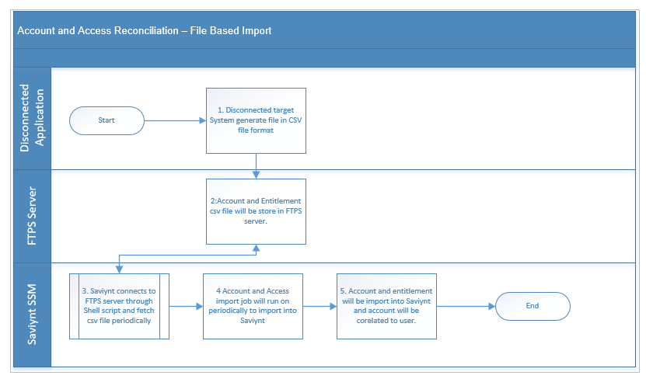
Description:
The following actions take place when a reconciliation is done
- Target system generate account and entitlement file in csv file format.
- Once account and entitlement file is placed on SFTP server.
- Saviynt Shell script connects to SFTP server to download csv file on Saviynt server.
- Once file is available on Saviynt server, account and entitlement import job runs on schedule based in Saviynt.
Below are high level steps for the SFTP integration.
- File format needs to define as per below format
  - Entitlement File :- (Application Name)_CREDENTIALS_ENTITLEMENT_VALUES
e.g. : SMART_CREDENTIALS_ENTITLEMENT_VALUES
  - Account File :- SMART_USER_CRED_ACCOUNTS
(Application Name)_USER_CRED_ACCOUNTS
- Saviynt team will provide a shell script on Saviynt application server to connect to SFTP host and pull the required datafile into Saviynt’s saviynt/Import/Datafiles/ folder.
- Cronjobs on server to automate the process of retrieving the files
- Import jobs on Saviynt UI to import account and entitlement.

DMZ AD Account Password Reset

Process#2.1 – Maintenance Account Password Reset
Figure 34: DMZ Active Directory - Maintenance Account Password Reset
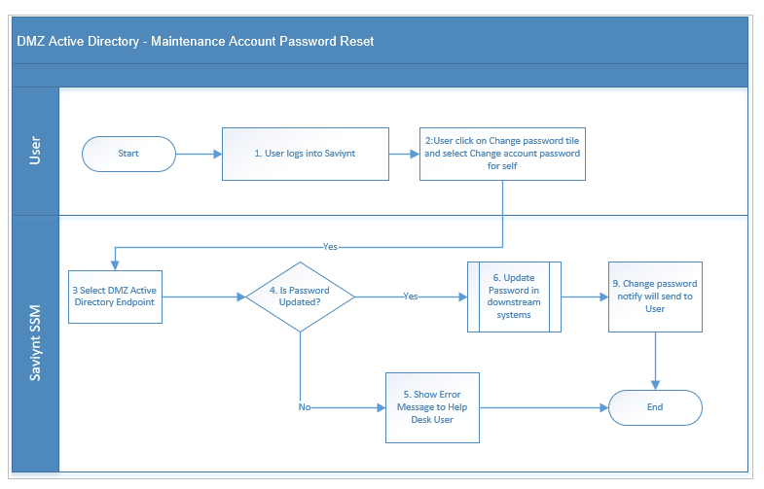
Description:
- User accesses Saviynt web console, logs into Saviynt using SSO, and accesses the Change password tile and select change account password for self.
- User prompted to enter a new password and confirm the password.
- Is Password Updated in Saviynt, continue to Step 4
- Update Password in downstream systems.
- Notify password to End User. Process End
If the password change is unsuccessful, Show error message. Process End.

Process#2.2 – Service and Generic Account Password Reset
Figure 35: DMZ Active Directory - Maintenance Account Password Reset
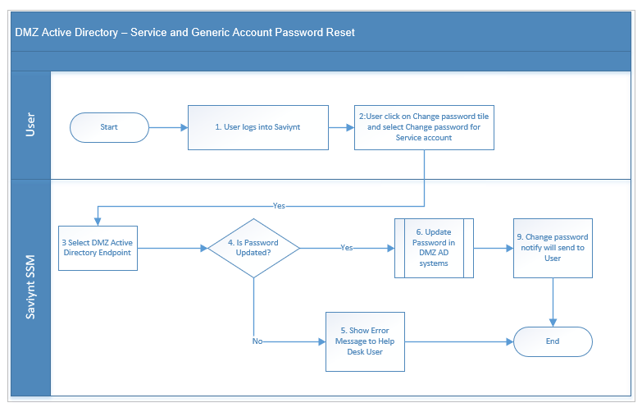
Description:
- User accesses Saviynt web console, logs into Saviynt using SSO, and accesses the Change password tile and select change password for service account.
- User prompted to enter a new password and confirm the password.
- Is Password Updated in Saviynt, continue to Step 4
- Update Password in downstream systems.
- Notify password to End User. Process End
If the password change is unsuccessful, Show error message. Process End.

DMZ Account Password Policy
The following section provides details about the DMZ Active Directory Password Policy.
Table 24: DMZ Active Directory Password Policy Service account
Policy Name | Hormel Active Directory Password Policy
Policy Description | This is Active Directory password policy for Hormel users.
Policy Scope | USER/DMZ Active Directory account
Maximum password age | 90 days
Minimum password age | 1 days
Minimum Digit Characters | 1
Minimum Special Character | 1
Minimum Uppercase Characters | 1
Minimum Length | 14
Last Password History | 24

Business Rules
This section lists and describes the business rules applicable to the proposed system.
Table 25: Business Rule
Business Rule ID | Rule Name | Rule Description
BR001 | Maintenance account  AccountName Generation Rule | The User Name generation logic will follow the below order for generating User Name until a non-duplicate User Name is generated.  mnt+firstname (1st character )+ middlename (1st character)+lastname (1st character) + autoincrement (if already accountname exists)
BR002 | Service account  AccountName Generation Rule | Saviynt creates Service account with following rule:-  mrdmz+(whatever function name).
BR003 | Generic account  AccountName Generation Rule | dmz+(whatever function name).
BR004 | CN Generation Rule for DMZ accounts | Maintenance account: accountName,HRLDMZ-Users-MaintenanceAccount OU  Service account: accountName,HRLDMZ-Users-ServiceAccounts OU  Generic account: accountName,HRLDMZ-Users-GenericAccounts OU

Scheduled Tasks
The following section provides details about the scheduled task that will be configured in SSM.
Table 26: Scheduled Task
# | Name | Description | Frequency / Ad-hoc
1 | DMZ_AD_FULL_ACCOUNT_RECON | Full import of accounts from Active Directory. (Full Target Reconciliation) | Every 8 hr.
2 | DMZ_AD_FULL_ENT_RECON | Full import of entitlements Active Directory. (Full Entitlements Load) | Every 8 hr.
3 | EMAIL_HISTORY_JOB | Saviynt job for sending approval notification | Every 5 min
4 | PROVISIONING_TRIGGER_JOB | Saviynt job for pending task processing for all application | Every 15 min
5 | DMZ_AD_REMOVE _ACCOUNT_90DAYS_RECON | Analytics job for removing AD account after 90 days of termination | Every Night
6 | CF_PLUS_FULL_ACCOUNT_RECON | Full import of accounts from CF PLUS. (Full Target Reconciliation) | Every 8 hr.
7 | CF_PLUS_FULL_ENT_RECON | Full import of entitlements CF Plus. (Full Entitlements Load) | Every 8 hr.
8 | FLAT_FILE_ACCOUNT_RECON | Import all account from Flat File for all configured application | Every 8 hr.
9 | FLAT_FILE_ENT_RECON | Import all Entitlement from Flat File for all configured application | Every 8 hr.
10 | ATTESTATION_EXPIRED_JOB | This job will configure to expire certification campaign | Every Night
11 | CERTIFICATION_REMINDER | Send reminder to certifier | Every Morning
12 | SEND_CONSULT_EMAIL_JOB | Send email notification on consult | Every 15 min
13 | CAMPAIGN_PROGRESSREF_RESH_JOB | Show progress on  Campaign | Every 15 min

Physical Design

Physical Architecture Overview

Development Environment
Figure 36: DEV Physical Architecture
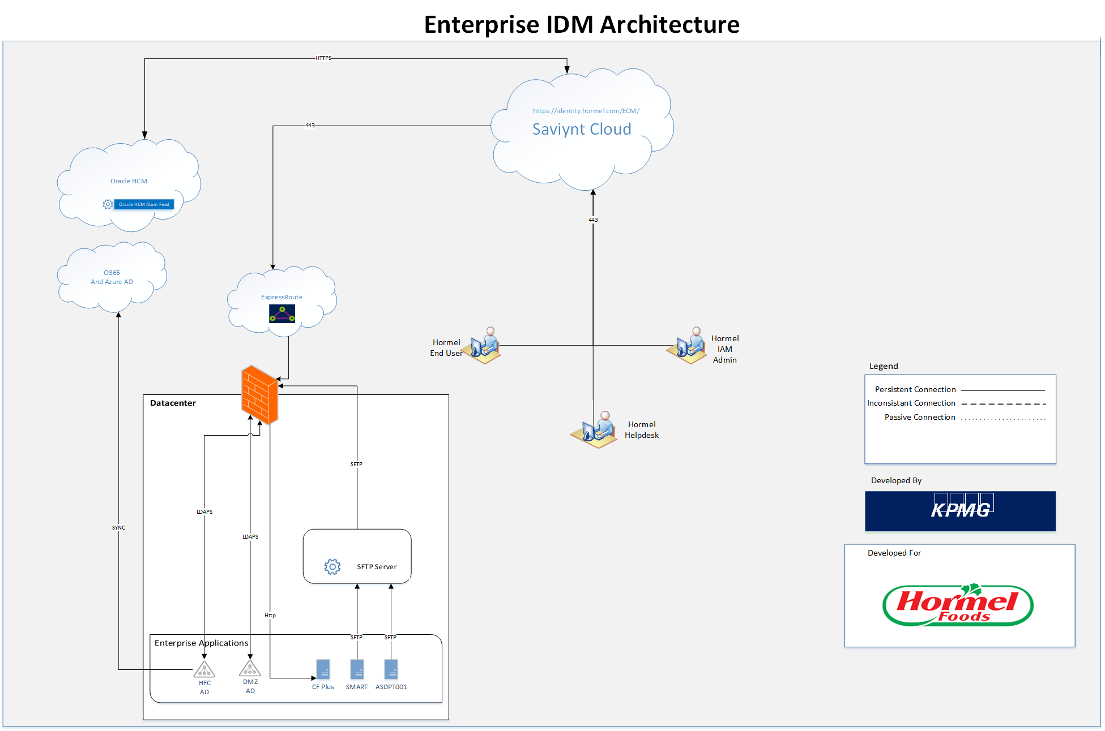
Below are the key points about DEV physical architecture for the IDM solution:
- The DEV infrastructure is created in <TBD> datacenter.
- The ExpressRoute is setup to facilitate the connection between SSM and enterprise applications.
- The enterprise SaaS applications are connected to SSM over internet.
- The enterprise firewall is configured to allow communication from SSM to enterprise servers/applications via ExpressRoute.
- SFTP Sever is configured to fetch disconnected application file from target system and Saviynt will fetch files that are stored on SFTP server.

Production Environment
Figure 37: PROD Physical Architecture
Below are the key points for PROD physical architecture for the IDM solution:
- For the enterprise, the PROD infrastructure is created in <TBD> data center.
- The ExpressRoute is setup to facilitate the connection between SSM and enterprise applications.
- The enterprise SaaS applications are connected to SSM over internet.
- The enterprise firewall is configured to allow communication from SSM to enterprise servers/applications via ExpressRoute.
- SFTP Sever is configured to fetch disconnected application file from target system and Saviynt will fetch files that are stored on SFTP server.
The enterprise firewalls are configured to allow communication via ExpressRoute to enterprise servers/applications.

Environment Mapping with Connected Systems
Table 27: Environment Mapping with Connected System
SSM | DMZ AD | CF PLUS
DEV | Production in a separate OU | DEV
UAT | Production in a separate OU | TEST
Prod | Production | Production

SSM Target (Downstream) Environment Details
- Following are the Dev environment details

Table 28: DEV Environment Details
Application | Server | Port
DMZ Active Directory (OU) | 172.16.42.1:636 | 636
CF PLUS | 172.16.60.80:1700/dweb | 1700

- Following are the UAT environment details

Table 29: UAT Environment Details
Application | Server | Port
DMZ Active Directory (OU) | 172.16.42.1:636 | 636
CF PLUS | 172.16.60.80:1705/tweb.hormel.com | 1705

- Following are the PROD environment details

Table 30: PROD Environment Details
Application | Server | Port
DMZ Active Directory (OU) | 172.16.42.1:636 | 636
CF PLUS | 172.16.60.64:1710/pweb | 1710

Hardware Components

Server Pre-requisites
Table 31: Server Pre-Requisites
Server | Description
SFTP Server | Name: lxcossav1d.hfc.ad  Address: 172.16.40.160

High Availability
High Availability pertains to capabilities that aim to reduce the downtime of a system due to faults.
Table 32: High Availability
Saviynt Cloud | Saviynt offers a reliable, fault-tolerant, and highly available system to meet enterprise needs. Saviynt supports load balancing and clustering at various levels to provide HA solution and uses real-time replication to support failover mode.  High Availability of all cloud-hosted components is natively supported by Saviynt. It is assumed that availability SLAs are defined as part of Hormel’s subscription contracts.

Operations Design

Security
The Saviynt Security Manager (SSM) is a SaaS application and Saviynt is responsible for the Physical and Logical Security of its platform components that are hosted on the cloud.

Authentication
Table 33: Authentication
Component | Authentication Mechanism
Saviynt Cloud Web Interface | Saviynt Cloud is SSO enabled at Hormel and users will login to Saviynt using their Azure credentials. The Web Interface is accessible from anywhere – within or outside Hormel network perimeter.

Saviynt Operational Roles
The following list provides detailed entitlements of various Saviynt Roles that will be created. These roles provide appropriate capabilities to users within Saviynt.
Table 34: Saviynt Operational Roles
Saviynt Role Name | Linked Persona | Privileged Role? | Sub-Menu Entitlement Values
ROLE_HORMEL_ENDUSER | End-User | No
  SUBMENU.ADMIN.accounts_list
  SUBMENU.ARS.workflowmanagement_requesthome
  SUBMENU.ARS.jbpmworkflowmanagement_showmyhistoryrequests
  SUBMENU.ARS.jbpmworkflowmanagement_viewopenrequests
  SUBMENU.ARS.workflowmanagement_requesthomedashboard
  SUBMENU.ARS.workflowmanagement_remaccess
  SUBMENU.ARS.jbpmworkflowmanagement_remaccess
  SUBMENU.ARS.arsDashboard_remaccess
  SUBMENU.ARS.pmgmt_checkpasswordstrength
  SUBMENU.ARS.pmgmt_checkpasswordstrengthuserpolicy
  SUBMENU.ADMIN.pmgmt_resetpassword
  SUBMENU.ATTESTATION.campaign_list
  SUBMENU.CAMPAIGN.certification_list

Deployment Methodology
The current Saviynt product version, v5.5.0 SP3.9, does have fully supported export/import functionality for product configurations. The recommended approach from the Saviynt is to move the product configuration from one environment to another using transport functionality in Saviynt. KPMG Development team will work with the Saviynt team to move the implemented product configuration from DEV to PROD.

Backup and Recovery
Disaster recovery (DR) is an area of security planning that aims to protect an organization from the effects of significant negative events. Having a disaster recovery strategy in place enables an organization to maintain or quickly resume mission-critical functions following a disruption.

DR Terminology
- Recovery Time Objective (RTO): Once an outage/disruption occurs, this is the acceptable time frame within which an asset or business process needs to be recovered/restored in accordance to the set SLA levels.
- Recovery Point Objective (RPO): This refers to the point in time in the past to which the system will need to recover once an outage/disruption has occurred.
- The RPO is the point to which we will have all data up to that point recovered. The gap between the disaster and the RPO will likely be lost because of the disaster.
- On the timeline, RTO is the point at which the system will be back up and running. The gap between the disaster and the RTO is the timeframe for which the app will be down and non-functioning.

High-Level Backup and Archival Strategy
Table 35 : DR Terminology
Data | Storage | Technology | Typical Retention Period
Logs Backup | Application Server logs and Tomcat logs | Azure | Saviynt policy is to maintain logs for active viewing in Azure instance.  Application Logs will be maintained on Azure instance or a centralized logging server as per requirement.  - Logs up-to last 1 week will be persisted on Azure instance or (Centralized Logging Server).  - Logs which are older than 1 week will be purged.
Data Backup | Snapshot of RDS instance volumes | Azure | As per our backup policy, Saviynt stores snapshot of RDS instances.  The frequency of snapshots is 1 back-up per day at 10:00 AM UTC.  The retention policy for RDS as below:  - Retention Period for Prod: 30 days  - Retention Period for Non-Prod: 7 days

Patch and Upgrades
Table 36: Patch and Upgrade
Saviynt Cloud | All patching and upgrades will be handled automatically by the Saviynt team.

Health check monitoring
Table 37: Health Check Monitoring
Saviynt Cloud | Health check monitoring for Saviynt cloud is natively managed by Saviynt and Azure. SaaS typically obligated to inform organizations in case of environment availability issues that are outside the contractually obligated SLAs.

Logging
Saviynt provides a web interface to review and download server-level logs. Hormel’ IAM Administrators will have access for troubleshooting purpose.
Note: While the design document is being prepared, the above details are yet to be provided by Hormel. Once the details are provided, this section will be updated.

Certificates
- All certificates linked to SSM components will be managed by SSM.
- Certificates linked to DMZ Active Directory integration will need to be managed by the Hormel and Saviynt team.

Reports
SSM offers OOTB analytics capabilities that include SQL based reporting functionality. In the enterprise, it is vital to have system insight based on extensive reports for identity profiles and application accounts. Saviynt also offers actionable reports which include taking different actions like enable, accept, revoke, further review, etc. on the reports.
Table 38: Saviynt Analytics Report
Analytics Name | Description
Hormel DMZ Active Directory Failure Task | Provides the failure task details for Active Directory application
Hormel Reconciliation Failure | Provides reconciliation failure job details.
Hormel User/Service account orphan report | Provide list of account that are orphan into Saviynt.
Hormel Primary certifier missing | Provides list of account that do not have primary certifier
Hormel Remove account task | This report will generate remove task report for disconnected application.

Requirements Traceability Matrix
Table 39: Requirement Traceability Matrix
# | Process | Front End – UX | Back end  Components
1.1 | Approval Process – DMZ Active Directory, Generic, and Service Account. | Not Applicable | Section 4.10 – Approval Workflow  Section 9.2 - Notifications
1.2 | Provisioning – DMZ Active Directory Maintenance account. | Section 3.3.1 | Section 4.3 – DMZ Active Directory Connector Design  Section 9.2 - Notifications
1.3 | Provisioning – DMZ Active Directory Generic and Service account. | Not Applicable | Section 4.3 – DMZ Active Directory Connector Design  Section 4.4.5 – DMZ Active Directory Service Account Creation
1.4 | Enable – DMZ Maintenance Account | Not Applicable | Section 4.3 – DMZ Active Directory Connector Design  Section 4.4.8 – DMZ Active Directory Account Rehire
2.1 | Deprovisioning – DMZ Maintenance Account | Not Applicable | Section 4.3 – DMZ Active Directory Connector Design  Section 4.4.6 – DMZ Active Directory Account disable  Section 4.4.7 – DMZ Active Directory Account delete
2.2 | Maintenance Account Password Reset | Section 3.3.4 | Section 4.12.1 – Maintenance Account Password Reset
2.3 | Service and Generic Account Password Reset | Section 3.3.4 | Section 4.12.1 – Service and Generic Account Password Reset
2.4 | User Manager Certification | Section 3.3.5 | Section 4.8 – User manager certification
2.5 | Service Account Owner Certification Campaign | Section 3.3.5 | Section 4.9- Service account owner Certification
2.6 | Account/Access Reconciliation |  | Section 4.11

Design Challenges and Decisions
Table 40: Design Challenges and Decision
Sr No | Problem Statement | ;li
1 | Remove consult from User Manager campaign | As consult functionality show entire user base or able to configure certifier manager to show which do not fulfill Hormel requirement. So, decision was made to disable consult option for user manager campaign.
2 | DMZ Account must be requested only for IT Department | DMZ account should only be requested if user has IT in department.
3 | For DMZ and HFC AD Maintenance account, employeenumber will mapped on target profile. | As we do not have any correlation for DMZ and HFC Maintenance account. Decision was made to update employeenumber on DMZ and HFC AD maintenance account.
4 | Import HFC AD service account as Service/Generic account type | In HFC AD for service account currently there is no any specific attribute that defines that account is service account.  So, decision was made to import service account into Saviynt then based on OU criteria calculate account type.
5 | File format for disconnected application | Saviynt supports csv flat file import. And currently disconnected system file format is different.  Decision was made that Hormel team will generate csv file format for disconnected application to import data into Saviynt.
6 | iSeries application will be configured as individual application | As iSeries has multiple application.  Decision was made that iSeries applications will be individually configured as single application in Saviynt.
7 | Load description for SMART application | No description for Smart disconnected system is available on flat file.  Decision was made to import description for account though csv file.
8 | Manually correlation iSeries application | For iSeries application as there is no correlation attribute. All account will import into Saviynt though flat file as an orphan account.  Decision was made once Saviynt generate report for orphan account then Hormel team will manually or Bulk load to correlate account.
9 | Remove password from email DMZ AD Account create template | Once account is created into DMZ AD user need to reset password though change password utility from Saviynt.
10 | Remove Task will generate for disconnected in Saviynt | In certification campaign when disconnected application account is remove then remove account task is triggered into Saviynt. Report will be generated for remove account task for disconnected application and then respective application team member need to close task manually in Saviynt.

Appendix

Key Terminologies
Table 41: Key Terminologies
Terminology | Definition
Employee | Full / Part-time Employees who are managed via the Hormel’s HR system.
Other Users | Contractor / Consultants /Brokers who are managed in Hormel’s HR system and Active Directory currently.
Identity | Identity is a system of record that is uniquely associated with a user within an organization. Each user, Full time, part-time, contractor or consultant within Hormel should have one and only one identity. In mature IAM programs, an identity is uniquely defined using a Global Unique Id (GUID), which would stay with the user for life.
Account | An account is a system of record that is associated with various technologies users gain access to, for example, Active Directory, Salesforce, etc. An IAM system would link identities to accounts across various integrated technologies. An identity may have none, one or more accounts based on the environment. If an account can’t be associated with an identity, it is considered an orphan account. Having such accounts adds the risk of unauthorized access to an organization.
Up-stream System | An Up-stream system refers to the authoritative source of user records within an organization. At Hormel, Oracle HCM is considered the up-stream system for Employees and Contingent Worker.
Down-stream system | A downstream system refers to integration applications or technologies in which accounts are managed by IAM technologies. For the scope of this engagement, downstream systems collectively refer to DMZ and HFC AD.
Entitlement Owner | Set of users who are approver for the Active Directory groups assignment.
Trusted Reconciliation | Reconciliation of Identities from a trusted source( Oracle HCM). All the user identity record is reconciled into SSM by using the HCM_IMPORT_JOB.
Target Reconciliation | All the Account and Access are reconciled from the Down-stream application into SSM by using Scheduling Job.

Notifications
In the enterprise, the IDM solution will be responsible for sending notification emails to the appropriate users/teams as required. SSM’s OOTB email templates will be leveraged to create the email notifications. The Enterprise SMTP server will be used to facilitate the email delivery to the users, managers, and other relevant teams.
The IDM notification will not be configurable as actionable. These emails will be ‘DO NOT REPLY’ type system notifications. This section describes the notifications template that is the reference in the Process Document.

N01# DMZ Active Directory User Account Creation
Table 42: DMZ Active Directory User Account Creation
DMZ Active Directory User Account Creation
Type | Text
From | noreply@hormel.com
To | User
Cc/Bcc
Subject | DMZ Active Directory User Account Provisioned - ${user?.firstname} ${user?.lastname}
Message | Dear ${manager?.firstname} ${manager?.lastname},  You are receiving this email from the Access Central Administrator to alert you that a new account has been created in ${task?.endpoint?.displayName} for ${user?.firstname} ${user?.lastname} [${task?.accountName}].  Login Information  User ID: ${user?.username}  Please communicate these credentials to the new user. If the new user has an assigned Hormel workstation, they should log in and they will be prompted to reset their password upon first login.  If you have any questions please log onto Service Central and create a ticket. Do not reply to this email as the mailbox is not monitored.  Thank You,  Access Central Administrator

N02# DMZ Active Directory User Account Disable
Table 43: DMZ Active Directory User Account Disable
DMZ Active Directory User Account Disable
Type | Text
From | noreply@hormel.com
To | Users Manager
Cc/Bcc
Subject | DMZ Active Directory User Account Disable- ${user?.firstname} ${user?.lastname}
Message | Dear ${manager?.firstname} ${manager?.lastname},  You are receiving this email from the Access Central Administrator to alert you that an account has been disabled in ${task?.endpoint?.displayName} for ${user?.firstname} ${user?.lastname}  Login Information  User ID: ${user?.username}  If you have any questions please log onto Service Central and create a ticket. Do not reply to this email as the mailbox is not monitored.  Thank You,  Access Central Administrator

N03# DMZ Active Directory User Account Enable
Table 44: DMZ Active Directory User Account Enable
DMZ Active Directory User Account Enable
Type | Text
From | noreply@hormel.com
To | Users Manager
Cc/Bcc
Subject | DMZ Active Directory User Account Enable - ${user?.firstname} ${user?.lastname}
Message | Dear ${manager?.firstname} ${manager?.lastname},  You are receiving this email from the Access Central Administrator to alert you that an account has been enabled in ${task?.endpoint?.displayName} for ${user?.firstname} ${user?.lastname}  Login Information  User ID: ${user?.username}  If you have any questions please log onto Service Central and create a ticket. Do not reply to this email as the mailbox is not monitored.  Thank You,  Access Central Administrator

N04# DMZ Active Directory User Account Deleted
Table 45: DMZ Active Directory User Account Deleted
DMZ Active Directory User Account Enable
Type | Text
From | noreply@hormel.com
To | Users Manager
Cc/Bcc
Subject | Active Directory User Account Deleted - ${user?.firstname} ${user?.lastname}
Message | Dear ${manager?.firstname} ${manager?.lastname},  You are receiving this email from the Access Central Administrator to alert you that an account has been deleted in ${task?.endpoint?.displayName} for ${user?.firstname} ${user?.lastname}  Login Information  User ID: ${user?.username}  If you have any questions please log onto Service Central and create a ticket. Do not reply to this email as the mailbox is not monitored.  Thank You,  Access Central Administrator

N09# Access Request Assignment Email Notification
Table 46: Access Request Assignment Email Notification
Access Request Assignment Email Notification
Type | Text
From | noreply@hormel.com
To | ${assignee.email}
Cc/Bcc
Subject | Please review access request ID: ${requestid} for ${user.firstname} ${user.lastname} [${user.username}].
Message | Dear ${assignee?.firstname} ${assignee?.lastname},  You are receiving this email from the Access Central Administrator to alert you that Access request ID: ${requestid} has been submitted for ${user.firstname} ${user.lastname} [${user.username}]. This request has been submitted by ${requestor.firstname} ${requestor.lastname} [${requestor.username}].  The request is for the following application and access:  Application Name: ${endpoint}  Entitlements:${entitlement_values?.displayname}  Please login to Access Central application to view details and complete this request. If no action is taken by ${(request.requestdate + 4).format("MMMM dd, yyyy")}, the request will be assigned to your manager. The request will be expired on ${(request.requestdate + 10).format("MMMM dd, yyyy")}.  If you have any questions please log onto Service Central and create a ticket. Do not reply to this email as the mailbox is not monitored.  Thank You,  Access Central Administrator

N10# Access Request Reminder Email Notification
Table 47: Access Request Reminder Email Notification
Access Request Reminder Email Notification
Type | Text
From | noreply@hormel.com
To | ${assignee.email}
Cc/Bcc
Subject | Access request reminder for request ID: ${requestid} for ${user.firstname} ${user.lastname}.
Message | Dear ${assignee?.firstname} ${assignee?.lastname},  You are receiving this email from the Access Central Administrator to alert you that Access request ID: ${requestid} has not been completed by you for ${user.firstname} ${user.lastname} [${user.username}].If no action is taken by ${(request.requestdate + 4).format("MMMM dd, yyyy")}, the request will be assigned to your manager. The request will be expired on ${(request.requestdate + 10).format("MMMM dd, yyyy")}.  The request is for the following application and access:  Application Name: ${endpoint}  Entitlements:${entitlement_values?.displayname}  Please login to Access Central application to view details and complete this request.  If you have any questions please log onto Service Central and create a ticket. Do not reply to this email as the mailbox is not monitored.  Thank You,  Access Central Administrator

N11# Access Request Reassignment Email Notification
Table 48: Access Request Reassignment Email Notification
Access Request Reassignment Email Notification
Type | Text
From | noreply@hormel.com
To | ${assignee.email}
Cc/Bcc
Subject | Please review access request ID: ${requestid} for ${user.firstname} ${user.lastname} [${user.username}].
Message | Dear ${assignee?.firstname} ${assignee?.lastname},  You are receiving this email from the Access Central Administrator to alert you that Access request ID: ${requestid} has not been completed by previous approver and has been escalated to you for further action. This request has been submitted by ${requestor.firstname} ${requestor.lastname} [${requestor.username}] for ${user.firstname} ${user.lastname} [${user.username}].  The request is for the following application and access:  Application Name: ${endpoint}  Entitlements: ${entitlement_values?.displayname}  Please login to Access Central application to view details and complete this request. If no action is taken by ${(request.requestdate + 10).format("MMMM dd, yyyy")}, the request will be cancelled.  If you have any questions please log onto Service Central and create a ticket. Do not reply to this email as the mailbox is not monitored.  Thank You,  Access Central Administrator

N12# Access Request Approved Email Notification
Table 49: Access Request Approved Email Notification
Access Request Approved Email Notification
Type | Text
From | noreply@hormel.com
To | ${requestor.email}
Cc/Bcc
Subject | Access request approved request ID: ${requestid} for ${user.firstname} ${user.lastname} [${user.username}].
Message | Dear ${requestor?.firstname} ${requestor?.lastname},  You are receiving this email from the Access Central Administrator team to alert you that Access request ID: ${requestid} has been approved for ${user.firstname} ${user.lastname} [${user.username}].  The request is for the following application and access:  Application Name: ${endpoint}  Entitlements: ${entitlement_values?.displayname}  Please login to Access Central application to view more details of this request.  If you have any questions please log onto Service Central and create a ticket. Do not reply to this email as the mailbox is not monitored.  Thank You,  Access Central Administrator

N13# Access Request Rejected Email Notification
Table 50: Access Request Rejected Email Notification
Access Request Rejected Email Notification
Type | Text
From | noreply@hormel.com
To | ${requestor.email}
Cc/Bcc
Subject | Access request rejected with request ID: ${requestid} for ${user.firstname} ${user.lastname} [${user.username}].
Message | Dear ${requestor?.firstname} ${requestor?.lastname},  You are receiving this email from the Access Central Administrator to alert you that Access request ID: ${requestid} has been rejected for ${user.firstname} ${user.lastname} [${user.username}].  The request is for the following application and access:  Application Name: ${endpoint}  Entitlements:${entitlement_values?.displayname}  Please login to Access Central application to view more details of this request.  If you have any questions please log onto Service Central and create a ticket. Do not reply to this email as the mailbox is not monitored.  Thank You,  Access Central Administrator

N14# Access Request Expired Email Notification
Table 51: Access Request Expired Email Notification
Access Request Expired Email Notification
Type | Text
From | noreply@hormel.com
To | ${requestor.email}
Cc/Bcc
Subject | Access request expired request ID: {requestid} for {user.firstname} {user.lastname} [{user.username}].
Message | Dear ${requestor?.firstname} ${requestor?.lastname},  You are receiving this email from the Access Central Administrator to alert you that Access request ID: ${requestid} has been expired.  Please login to Access Central application to view more details of this request.  If you have any questions please log onto Service Central and create a ticket. Do not reply to this email as the mailbox is not monitored.  Thank You,  Access Central Administrator

N15# Account Request Assignment Email Notification
Table 52: Account Request Assignment Email Notification
Account Request Assignment Email Notification
Type | Text
From | noreply@hormel.com
To | ${assignee.email}
Cc/Bcc
Subject | Please review access request ID: ${requestid} for ${user.firstname} ${user.lastname} [${user.username}].
Message | Dear ${assignee?.firstname} ${assignee?.lastname},  You are receiving this email from the Access Central Administrator to alert you that Access request ID: ${requestid} has been submitted for ${user.firstname} ${user.lastname} [${user.username}]. This request has been submitted by ${requestor.firstname} ${requestor.lastname} [${requestor.username}].  The request is for the following application :  Application Name: ${endpoint}  Please login to Access Central application to view details and complete this request. If no action is taken by ${(request.requestdate + 4).format("MMMM dd, yyyy")}, the request will be assigned to your manager. The request will be expired on ${(request.requestdate + 10).format("MMMM dd, yyyy")}.  If you have any questions please log onto Service Central and create a ticket. Do not reply to this email as the mailbox is not monitored.  Thank You,  Access Central Administrator

N16# Account Request Reminder Email Notification
Table 53: Account Request Reminder Email Notification
Account Request Reminder Email Notification
Type | Text
From | noreply@hormel.com
To | ${assignee.email}
Cc/Bcc
Subject | Account request reminder for request ID: ${requestid} for ${user.firstname} ${user.lastname}.
Message | Dear ${assignee?.firstname} ${assignee?.lastname},  You are receiving this email from the Access Central Administrator to alert you that Access request ID: ${requestid} has not been completed by you for ${user.firstname} ${user.lastname} [${user.username}].If no action is taken by ${(request.requestdate + 4).format("MMMM dd, yyyy")}, the request will be assigned to your manager. The request will be expired on ${(request.requestdate + 10).format("MMMM dd, yyyy")}.  The request is for the following application:  Application Name: ${endpoint}  Please login to [Access Central] application to view details and complete this request.  If you have any questions please log onto Service Central and create a ticket. Do not reply to this email as the mailbox is not monitored.  Thank You,  Access Central Administrator

N17# Account Request Reassignment Email Notification
Table 54: Account Request Reassignment Email Notification
Account Request Reassignment Email Notification
Type | Text
From | noreply@hormel.com
To | ${assignee.email}
Cc/Bcc
Subject | Please review access request ID: ${requestid} for ${user.firstname} ${user.lastname} [${user.username}].
Message | Dear ${assignee?.firstname} ${assignee?.lastname},  You are receiving this email from the Access Central Administrator to alert you that Access request ID: ${requestid} has not been completed by previous approver and has been escalated to you for further action. This request has been submitted by ${requestor.firstname} ${requestor.lastname} [${requestor.username}] for ${user.firstname} ${user.lastname} [${user.username}].  The request is for the following application:  Application Name: ${endpoint}  Please login to Access Central application to view details and complete this request. If no action is taken by ${(request.requestdate + 10).format("MMMM dd, yyyy")}, the request will be cancelled.  If you have any questions please log onto Service Central and create a ticket. Do not reply to this email as the mailbox is not monitored.  Thank You,  Access Central Administrator

N18# Account Request Approved Email Notification
Table 55: Account Request Approved Email Notification
Account Request Approved Email Notification
Type | Text
From | noreply@hormel.com
To | ${requestor.email}
Cc/Bcc
Subject | Account request approved request ID: ${requestid} for ${user.firstname} ${user.lastname} [${user.username}].
Message | Dear ${requestor?.firstname} ${requestor?.lastname},  You are receiving this email from the Access Central Administrator to alert you that Access request ID: ${requestid} has been approved for ${user.firstname} ${user.lastname} [${user.username}].  The request is for the following application:  Application Name: ${endpoint}  Please login to Access Central application to view more details of this request.  If you have any questions please log onto Service Central and create a ticket. Do not reply to this email as the mailbox is not monitored.  Thank You,  Access Central Administrator

N19# Account Request Rejected Email Notification
Table 56: Account Request Rejected Email Notification
Account Request Rejected Email Notification
Type | Text
From | noreply@hormel.com
To | ${requestor.email}
Cc/Bcc
Subject | Account request rejected with request ID: ${requestid} for ${user.firstname} ${user.lastname} [${user.username}].
Message | Dear ${requestor?.firstname} ${requestor?.lastname},  You are receiving this email from the Access Central Administrator to alert you that Access request ID: ${requestid} has been rejected for ${user.firstname} ${user.lastname} [${user.username}].  The request is for the following application :  Application Name: ${endpoint}  Please login to Access Central application to view more details of this request.  If you have any questions please log onto Service Central and create a ticket. Do not reply to this email as the mailbox is not monitored.  Thank You,  Access Central Administrator

N20# Account Request Expired Email Notification
Table 57: Account Request Expired Email Notification
Account Request Expired Email Notification
Type | Text
From | noreply@hormel.com
To | ${requestor.email}
Cc/Bcc
Subject | Request expired request ID: ${requestid} for ${user.firstname} ${user.lastname} [${user.username}].
Message | Dear ${requestor?.firstname} ${requestor?.lastname},  You are receiving this email from the Access Central Administrator to alert you that Access request ID: ${requestid} has been expired.  The request is for the following application:  Application Name: ${endpoint}  Please login to Access Central application to view more details of this request.  If you have any questions please log onto Service Central and create a ticket. Do not reply to this email as the mailbox is not monitored.  Thank You,  Access Central Administrator

21# DMZ Active Directory Account Deleted Today Report
Table 58: DMZ Active Directory Account Deleted Today Report
Active Directory Account Deleted Today Report
Type | Text
From | noreply@hormel.com
To
Cc/Bcc
Subject | Report of DMZ Active Directory Account Deleted Today
Message | Dear Admin,  This is to notify you the list of users Active Directory account deleted today.Kindly find the attached report with user’s details.  Please login to Access Central application and take action.  Thank You,  Access Central Administrator

N25# Reconciliation Job Failure Report
Table 59: Reconciliation Job Failure Report
Reconciliation Job Failure Report
Type | Text
From | noreply@hormel.com
To
Cc/Bcc
Subject | [Alert : Action Required] Saviynt Reconciliation Job Failure Report
Message | Dear IAM Admin,  This is to notify you that some of reconcilation jobs in Saviynt has failed.Kindly find the attached failure report.  Please login to Access Central application and take action.  Thank You,  Access Central Administrator

N26# DMZ Active Directory Task Failure Report
Table 60: Active Directory Task Failure Report
DMZ Active Directory Task Failure Report
Type | Text
From | noreply@hormel.com
To
Cc/Bcc
Subject | [Alert : Action Required] DMZ Active Directory Task Failure Report From Saviynt
Message | Dear Admin,  This is to notify you that some of the Active Directory tasks in Saviynt have failed.View the attached failure report for additional details.  Please login to Access Central application and take action.  Thank You,  Access Central Administrator

N27# User Manager Campaign Notification
Below attached sheet will be used to configure user manager campaign email template.

N28# Service Account owner campaign Notification
Below attached sheet will be used to configure Service account owner campaign email template.

Certification Campaign

User manager campaign
Below attached sheet defines how user manager campaign will be configured.

Service Account Owner campaign
Below attached sheet defines how user manager campaign will be configured.

